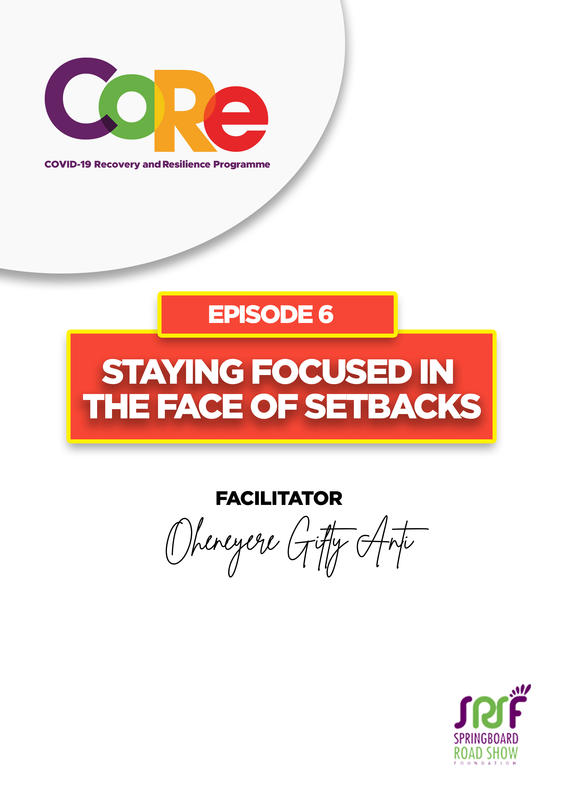
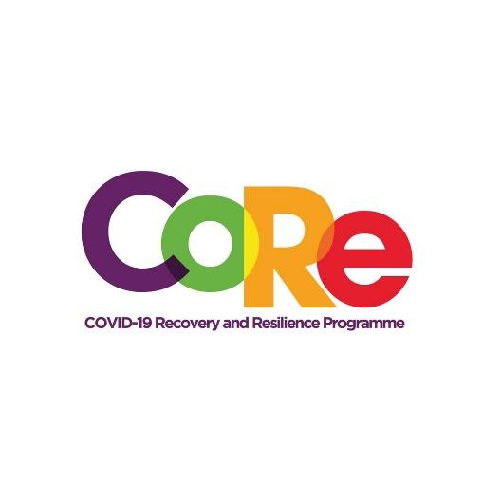


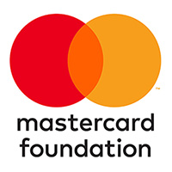

A partnership between

WORKBOOK
This workbook is a personal guide designed to accompany the CoRe Programme’s audio and video lesson for the week. Download it for free on our website www.core.com.gh

1. Assess your progress in life by thinking carefully about the following questions:
- Where am I going in life?
- Can I achieve my goals?
- Can I become somebody?
- Can I live my dreams?

Based on these four questions, would you say you are making progress in life? Why?

2. A setback is something that stops you in the middle of your journey. A setback can be a problem, complication, difficulty, or misfortune.

Based on this definition, what is the biggest setback you have faced this year?

3. A goal is a dream or objective you want to achieve. It is also an aim or a desired result.

What is the biggest goal you are pursuing this year?

Think through these questions concerning your big goal.
- Why am I doing this?
- Why did I decide to start this journey?
- Why do I want to become this person?
- How desperately do I want this?
- Is it worth it?

Self-Improvement Tips from Oheneyere Gifty Anti
To be focused is “to direct your attention, interest, or activity towards a particular aim.” Here are a few tips on how to stay focused on your goals and improve yourself in the process.

- You need to make sacrifices.
- You need to volunteer.
- You need to build a network.
- You need to listen to good programs, like the CoRe Programme.
- Choose right mentors that will direct you.
- Use technology (Emails, WhatsApp, Zoom, etc.) one day at a time.
- Do not waste the period.
- Do not waste your potential.
- Take calculated risk.
- Be adventurous.
- Open your eyes to various opportunities opened to you now.
- There is so much you can do.

4. Which two (2) of these 12 tips are you going to implement immediately?

- _________________________________________________________________________

- _________________________________________________________________________

5. Who do you want to choose as your mentor?

Why?

It is so important to us to hear from you.
- What is the biggest lesson you have learnt from this episode and the workbook?
- What one thing are you determined to do to help you stay focused in the face of setbacks?
- What question would you like to ask the facilitator?
Share your answers to these or any comments you may have on:
Facebook Page: https://web.facebook.com/CoReProgramme/
Twitter Page: https://twitter.com/CoreProgramme
Instagram Page: https://www.instagram.com/coreprogramme/
WhatsApp hotline (+233) 55 153 55 33 and we will respond to you within 24 hours.



