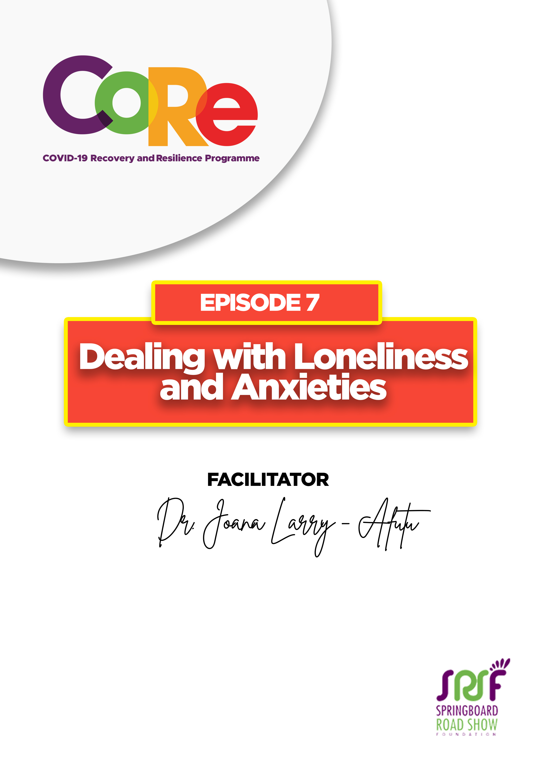
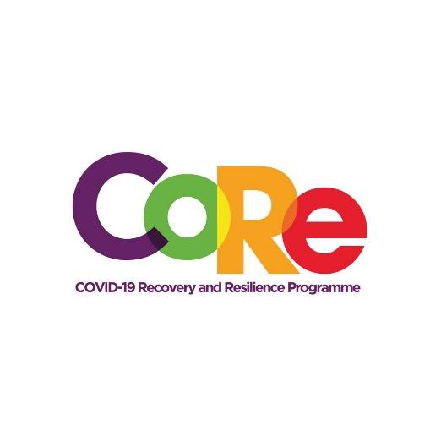




A partnership between

WORKBOOK
This workbook is a personal guide designed to accompany the CoRe Programme’s audio and video lesson for the week. Download it for free on our website www.core.com.gh

Name: _____________________________________________________________________

Phone Number: _____________________________________________________________

What is Loneliness?
Loneliness is an unpleasant emotional response to a real or perceived situation. For instance, you may feel lonely if no one believes in your vision. You may also feel lonely if your expectations are not met or if you lack support in these times of uncertainties with COVID-19. When you are lonely, you feel disconnected from other people.

Have you felt lonely lately? What do you think caused it?

What is Anxiety?
Uncertainties in life make us anxious. Anxiety is a feeling of worry, nervousness and fear. In these times of COVID-19, anxiety is normal because of the uncertainties surrounding the virus.

COVID-19 has filled so many people with anxiety because of the following:
- It is an uncommon disease and new information about it that keeps coming in each time.
- There is no idea about when a vaccine or cure for the COVID-19 virus will come.
- The protocols about the virus have completely changed our way of life.
- The increasing number of confirmed cases and deaths deepens existing anxieties.
- Stigmatization against people who have tested positive for COVID-19 and their families gives rise to a sense of loneliness.

Have you been anxious lately? What do you think contributed to your anxiety?

Ten tips for dealing with Anxieties, Loneliness and Uncertainties by Dr. Joana Larry-Afutu

- Acknowledge your feelings
- Manage your thoughts
- Change your attitude
- Support each other
- Say “No” to Stigmatization
- Connect with people with similar interest
- Do what you love
- Exercise
- Remain calm and be positive-minded
- Relax

Which 3 of these 10 tips are you going to practice regularly to help you deal with Anxieties, Loneliness and Uncertainties?

- _________________________________________________________________________

- _________________________________________________________________________

- _________________________________________________________________________

Has this session benefitted you?

Explain why or how

It is so important to us to hear from you.
- What is the biggest lesson you have learnt from this episode and the workbook?
- What one thing are you are going to do help you deal with loneliness and anxiety?
- What question would you like to ask the facilitator?
Share your answers to these or any comments you may have on:
Facebook Page: https://web.facebook.com/CoReProgramme/
Twitter Page: https://twitter.com/CoreProgramme
Instagram Page: https://www.instagram.com/coreprogramme/
WhatsApp hotline (+233) 55 153 55 33 and we will respond to you within 24 hours.



