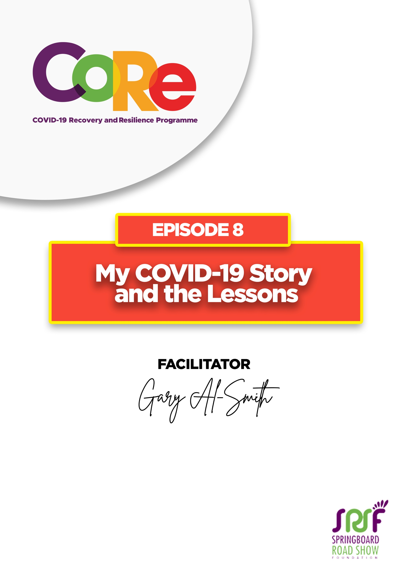
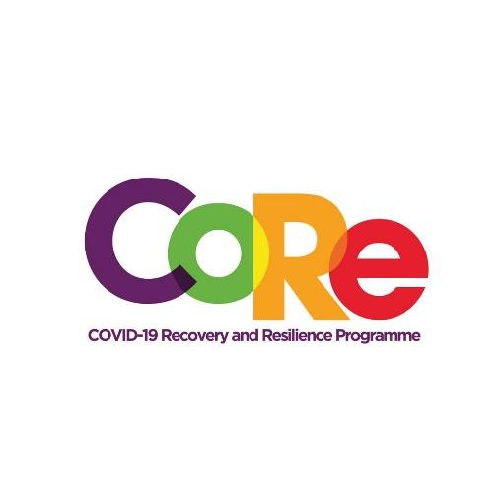




A partnership between

WORKBOOK
This workbook is a personal guide designed to accompany the CoRe Programme’s audio and video lesson for the week. Download it for free on our website www.core.com.gh

Name: _____________________________________________________________________

Phone Number: _____________________________________________________________

Stigmatization is negatively labeling someone because of a condition and treating them unfairly or publicly disapproving of them. According to Gary, there are different kinds of stigma. He focused on two types that could hinder the fight against COVID-19.

What is Self-stigmatization?
Self-stigmatization is when we accept that people who look down on us are right. It is accepting the wrong views others have about our condition. When we self-stigmatize, we feel sorry for ourselves, blame ourselves and feel like failures because we have COVID-19, another health issue or have been unsuccessful in something.

Gary Al-Smith recommends that people with COVID-19 or similar challenges keep themselves occupied to help overcome self-stigmatization. He recommends:
- Reading
- Engaging in activities you love

Have you looked down on yourself or felt unworthy lately?

What will you do from now to overcome it?

What is Courtesy Stigma?
Courtesy Stigma is stigmatizing somebody on behalf of somebody else. That is, when a person has COVID-19, a difficulty or a serious health issue and their close family or friends are stigmatized because of their situation.
Example: Some people refused to patronize Gary’s mother ‘s services because her son had COVID-19.

Have you looked down on someone or stigmatized them, their family, or friends because they have COVID-19?

What happens when we stigmatize people or their relations?

Lessons Learnt by Gary Al-Smith about his COVID-19 experience
a. Support each other through the COVID-19 experience
b. Observe all safety protocols put in place by health authorities.
- Observe social distancing
- Wear a face mask always when you go out or are with other people
- Regularly wash your hands with soap under running water
- Use alcohol-based hand sanitizers
c. Use your experience to reach out to others who may feel low, hopeless and think that this is the end of their lives.

From Gary’s lessons, what one thing are you going to do differently to support people who have COVID-19?

It is so important to us to hear from you.
- What is the biggest lesson you have learnt from this episode and the workbook?
- What one thing are you are going to do help yourself and others who have COVID-19?
- What question would you like to ask the facilitator?
Share your answers to these or any comments you may have on:
Facebook Page: https://web.facebook.com/CoReProgramme/
Twitter Page: https://twitter.com/CoreProgramme
Instagram Page: https://www.instagram.com/coreprogramme/
WhatsApp hotline (+233) 55 153 55 33 and we will respond to you within 24 hours.



