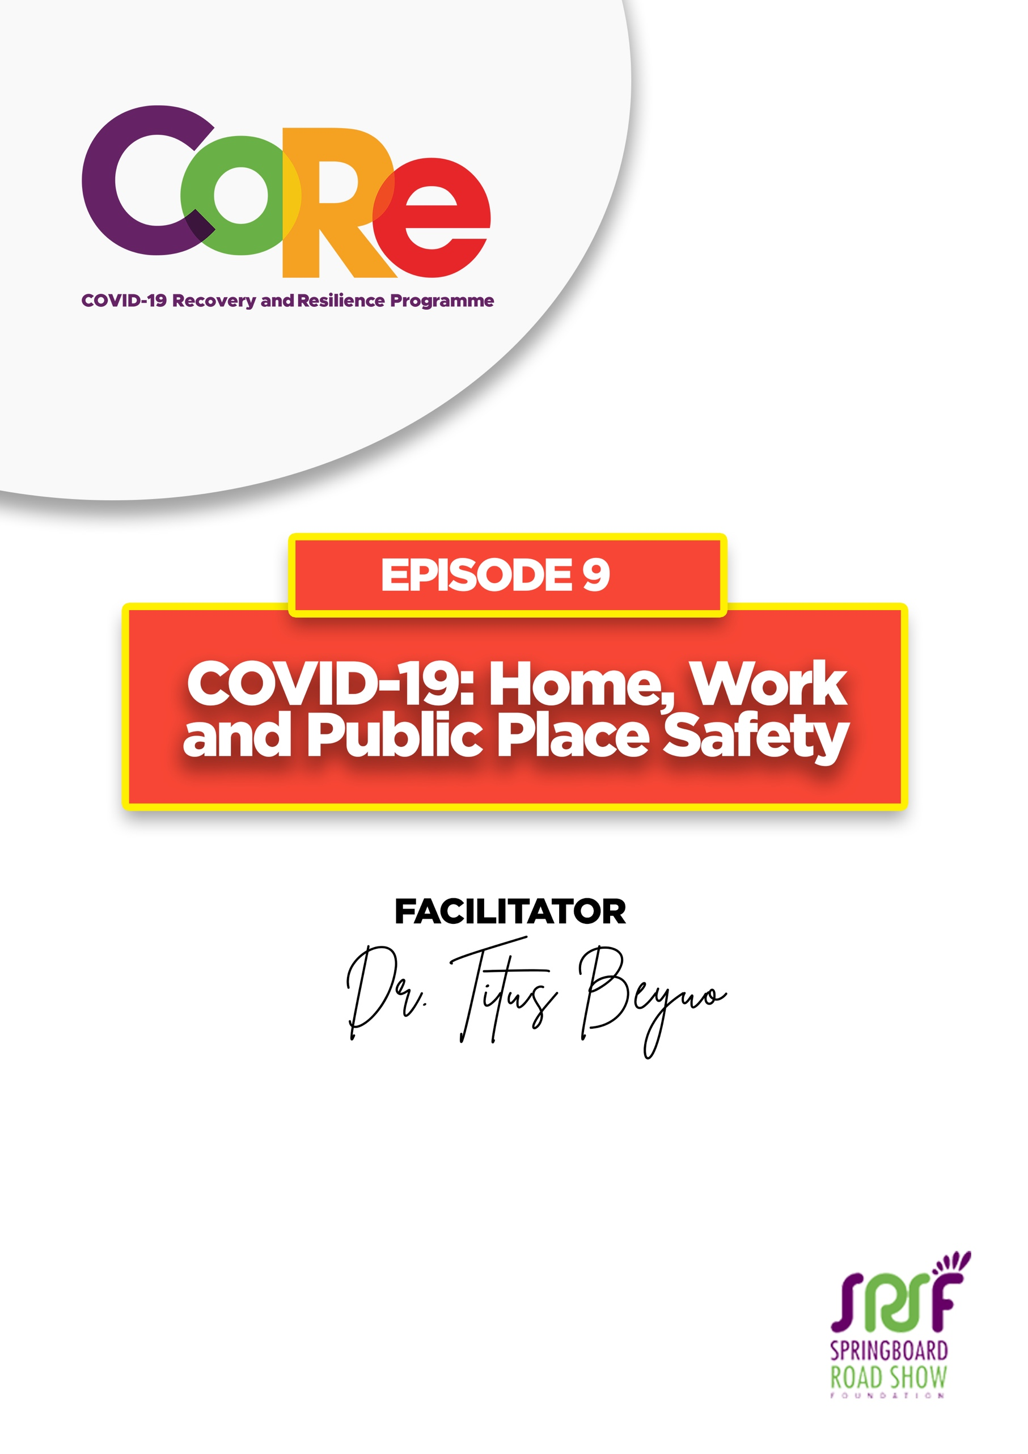
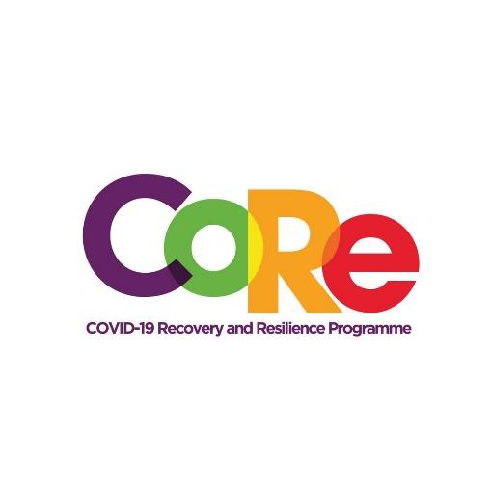




A partnership between

WORKBOOK
This workbook is a personal guide designed to accompany the CoRe Programme’s audio and video lesson for the week. Download it for free on our website www.core.com.gh

Name: _____________________________________________________________________

Phone Number: _____________________________________________________________

From today’s presentation, here are a few tips on staying safe during this COVID-19 pandemic era.

Home

Home infection can occur when we go out to work/ town, when someone comes to our home, through the things we carry home such money, items we buy or gifts we receive.

- Wash your hands, with soap under running water as soon as you get home
- Do not take footwears you used outside into parts of the home you walk barefooted such as the living room, bedroom, or kitchen.
- Hang the clothes you used outside, separately from others and wash them before you reuse them.
- Disinfect anything you carried with you such bags, items purchased, etc.
Workplace

- Always sanitize your hands after touching doorknobs in the workplace
- Sanitize your workstation or work area each morning before you start work
- Avoid direct face to face contact with people when speaking to them
- Ensure that, anyone who talks to you in the workplace has his/her mask on
Public Places

- If you decide to go to a public place, assume that everybody you are meeting there could be infected so you must protect yourself.
- Always wash/disinfect your hands when you touch anything. Until you wash/disinfect them, your hand(s) should not get to your Mouth, Eyes or Nose.
- Anybody coughing, singing, who is not wearing a face mask poses danger to you.
- Anyone at public gatherings with only face shields without a face mask, is not protecting himself and that person is not protecting you.

What one thing are you going to do to protect yourself and others in these places?
Home

Workplace

Public Place

It is so important to us to hear from you.
- What is the biggest lesson you have learnt from this episode and the workbook?
- What one thing are you are going to do protect yourself and those around you in this COVID-19 era?
- What question would you like to ask the facilitator?
Share your answers to these or any comments you may have on:
Facebook Page: https://web.facebook.com/CoReProgramme/
Twitter Page: https://twitter.com/CoreProgramme
Instagram Page: https://www.instagram.com/coreprogramme/
WhatsApp hotline (+233) 55 153 55 33 and we will respond to you within 24 hours.



