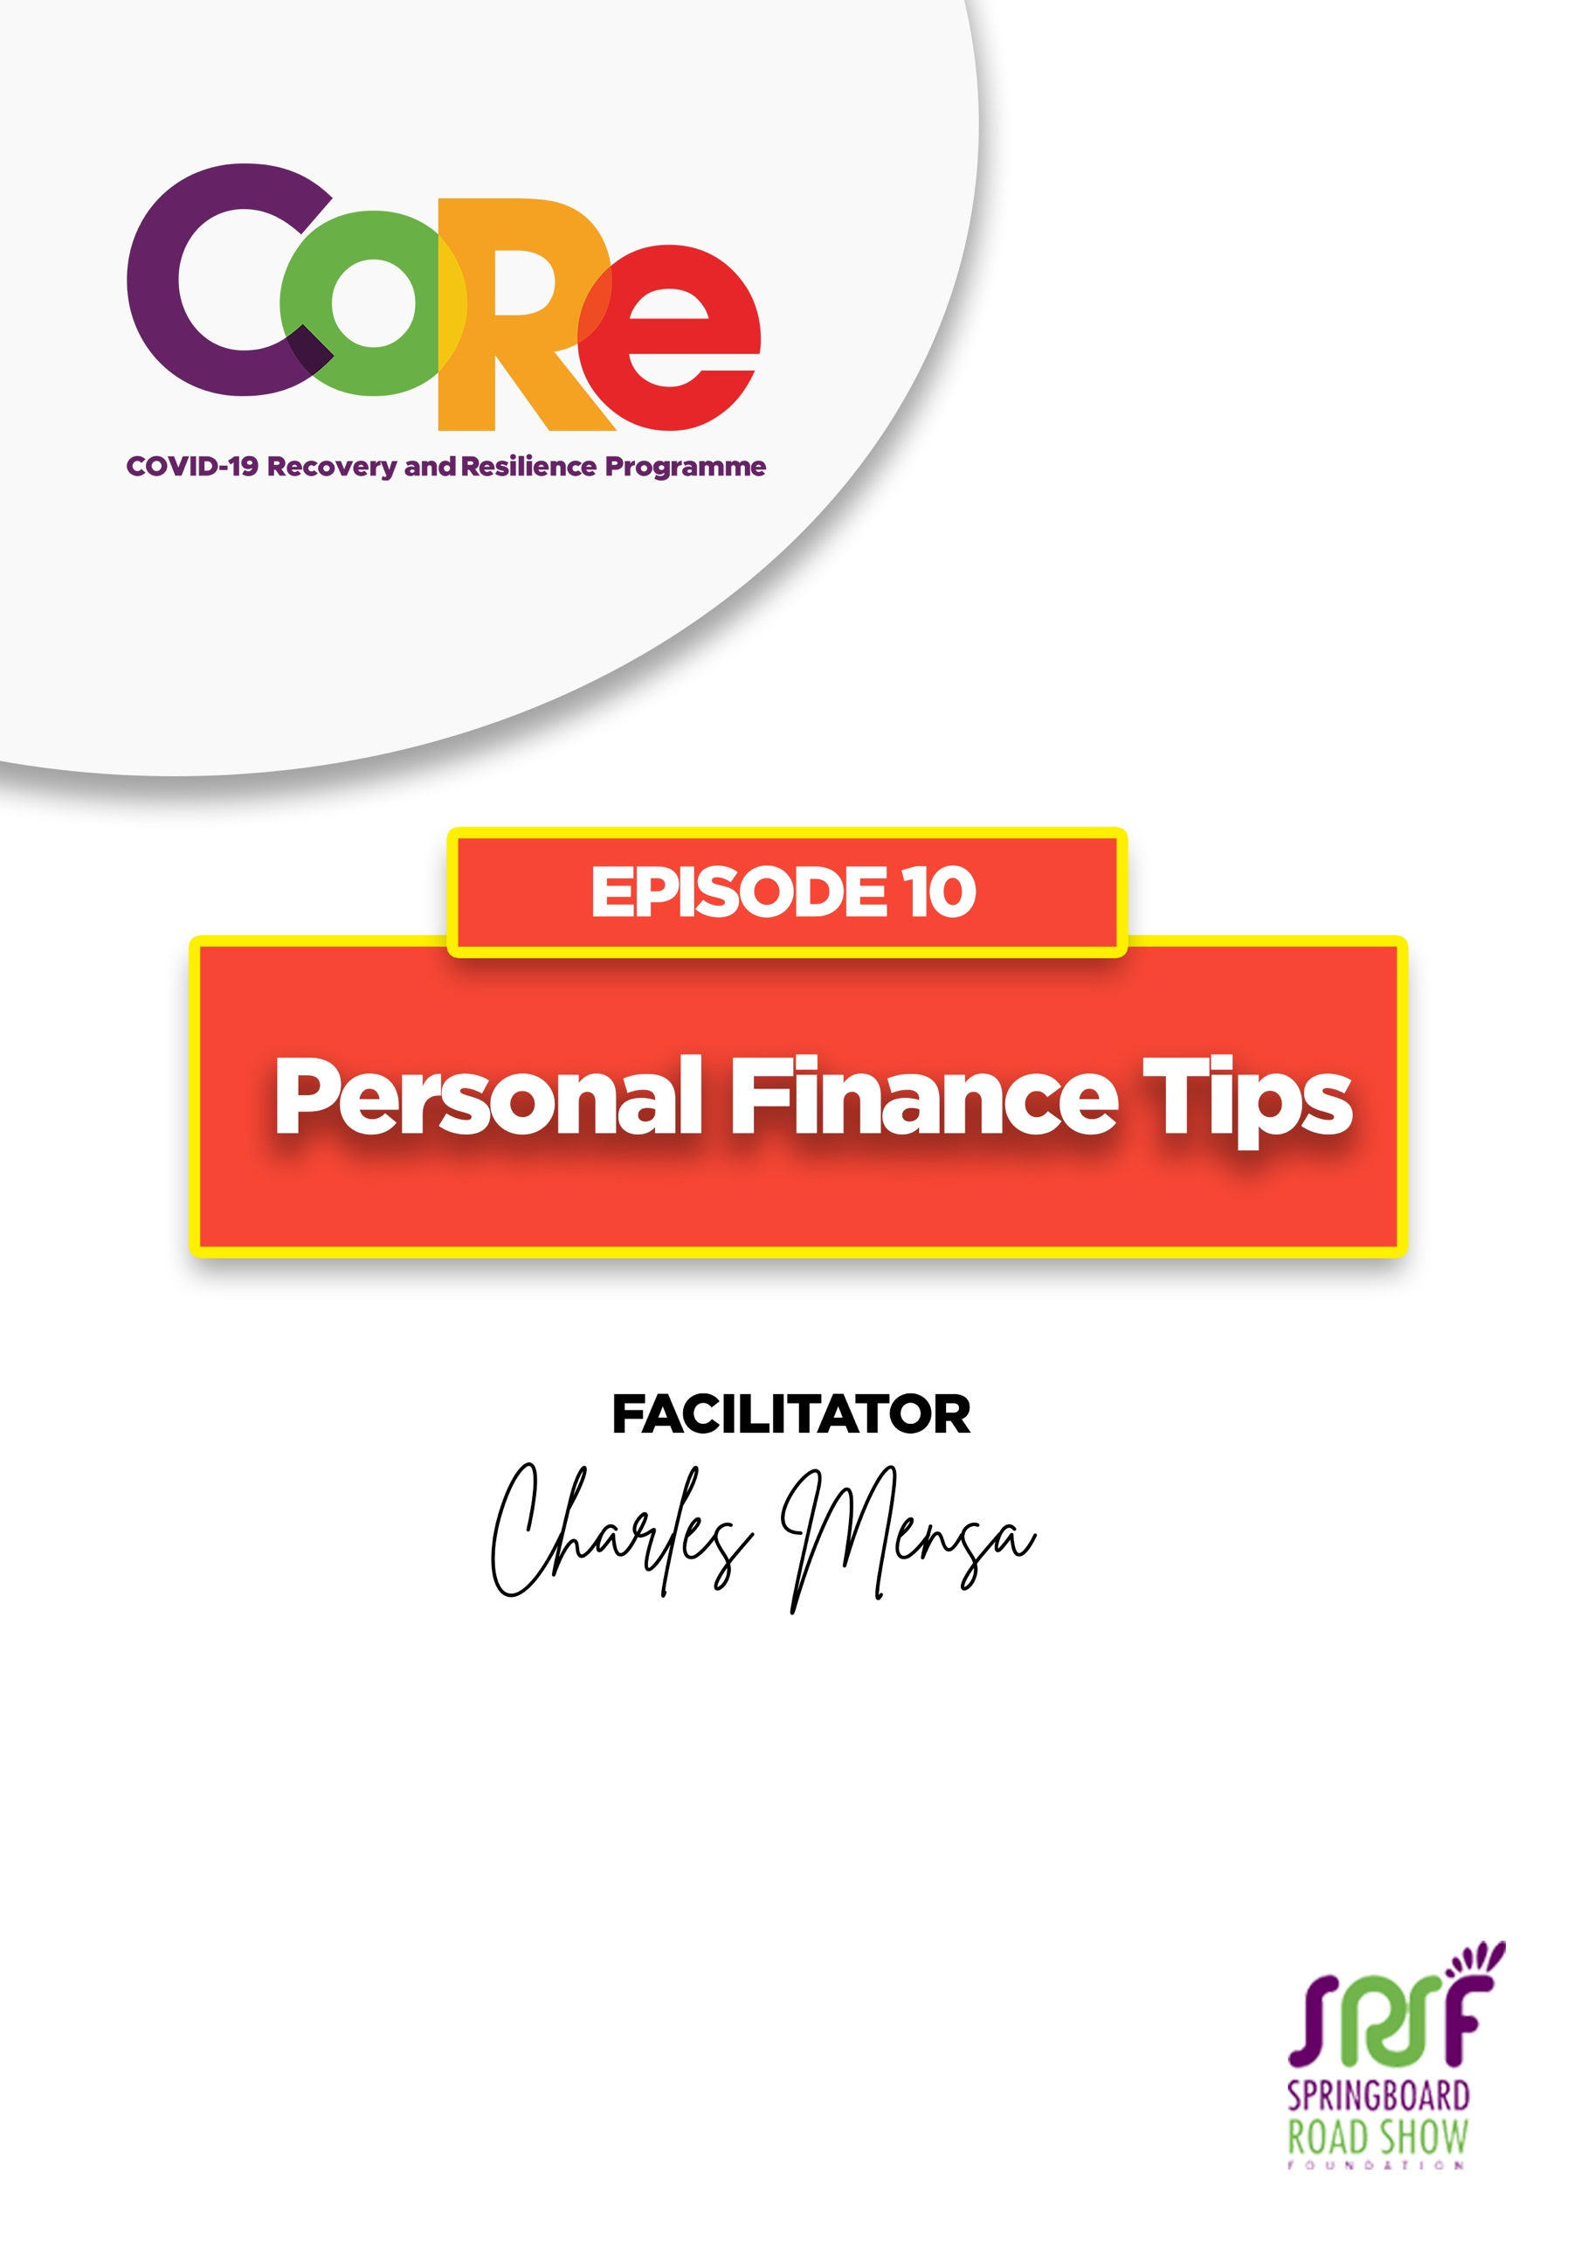
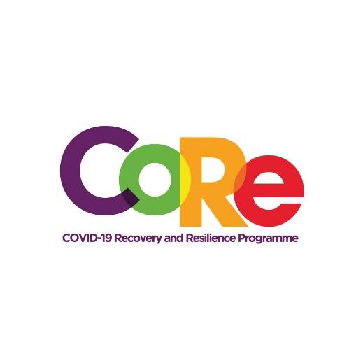




A partnership between

WORKBOOK
This workbook is a personal guide designed to accompany the CoRe Programme’s audio and video lesson for the week. Download it for free on our website www.core.com.gh

Name: _____________________________________________________________________

Phone Number: _____________________________________________________________

Personal Financial planning is the process of managing one's financial activities such as income generation, spending, saving, investing, and protection for a secured future. As a rule, you must not spend more than you earn.

Seven (7) Personal Finance Goals by Charles Mensa
- Whenever you borrow to spend, you mortgage your future.
- Improve your skills to enable you earn more income
- Plan your expenditures
- Plan for your committed expenses such as faith activities or external activities
- Plan for your investment; invest in your short, medium, and long-term goals
- Create a highlife account for entertainment
- Do not adjust your lifestyle when there is a cost saving

A THREE-STEP GUIDE TO BALANCING YOUR PERSONAL BUDGET

A. Make a list of your incomes and expenditures for each week/month
No. | Income | Expenditure
 | Example: Salary | Rent
Total

B. Add up your all income and all your expenditures

C. If the total of your incomes is more than your expenditures, you are making savings and living within your means. That points to good financial decisions. If the total of your expenditures is more than your incomes, you might be doing something wrong or overspending.

D. Should you find yourself overspending, review your accommodation or cut down on some of your key lines of expense in order to bring your expenses within your financial means.

Based on your learnings today, what will you do differently to secure your personal financial future?

I will___________________________________________________________________________

_______________________________________________________________________________

_______________________________________________________________________________

It is so important to us to hear from you.
- What is the biggest lesson you have learnt from this episode and the workbook?
- What one thing are you are going to do help you manage your finances?
- What question would you like to ask the facilitator?

Share your answers to these or any comments you may have on:
Facebook Page: https://web.facebook.com/CoReProgramme/
Twitter Page: https://twitter.com/CoreProgramme
Instagram Page: https://www.instagram.com/coreprogramme/
WhatsApp hotline (+233) 55 153 55 33 and we will respond to you within 24 hours.



