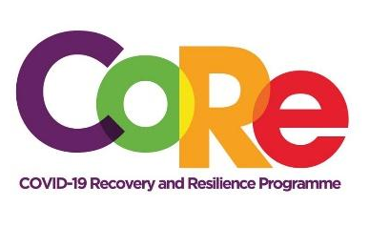
A collaboration between the Springboard Road Show Foundation, Mastercard Foundation and Solidaridad
WORKBOOK

Episode 2: “Doing Business with your Talent”
Facilitator: Albert Ocran
What is your main talent? ................................................................................................................................................
.......................................................................................................................................................................................................
List 4 things you can use your talent for.
No. | Example: I can use my cooking talent to provide lunch for offices

List of 4 categories of people you can serve with your talent (Your target audience)
Example: Workers in offices and banks

List 4 things your customers were expecting from you before the COVID-19 pandemic
Example: Convenient delivery of their orders

Based on recent happenings with COVID-19, list 3 concerns of your customers.
Example: Avoidance of infection

List 2 competitors who are doing similar things to you.
Example: the waakye seller by the roadside to the office of my customers

Mention 3 things your competitors are offering their customers.
Example: Free hand sanitizers with each order

Looking at your business, mention 3 people you will need to help grow your business.
Example: Delivery service

Based on what you’ve learnt, share 3 attitudes you should have towards your work.
No. | Example: I should always smile at my customers

What is your biggest lesson from this episode?

.......................................................................................................................................................................................................

.......................................................................................................................................................................................................

What one (1) change will you make as a result of what you've learnt?

………………………………………………………………………………………………………………………………………………

……………………………………………………………………………………………………………………………………………….

We hope you have enjoyed this exercise.
Visit our website www.core.com.gh and follow us on social media @CoreProgramme for more interesting sessions. For further information call 055 153 55 33

