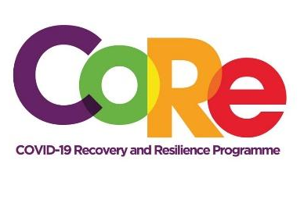
A collaboration between the Springboard Road Show Foundation, Mastercard Foundation and Solidaridad

WORKBOOK
This workbook is a personal guide designed to accompany the CoRe Programme’s audio and video lesson for the week. Download it for free on our website www.core.com.gh

Episode 3: “Doing Business ‘The New Normal’ way”
Facilitator: Albert Ocran

- Write down 2 lessons you learnt about “Change” from the story “Who Moved My Cheese?” by Dr. Spencer Johnson.
Example: Change can be very sudden.
1.________________________________________________________
2.________________________________________________________

- Identify two interesting or “New Normal” ideas you are using to do your business.
My Business | How I do Business normally | The disruptions I am experiencing | The New Normal
Example: Catering | Preparing African dishes for my clients | Some clients have stopped coming to my restaurant for fear of being infected | Delivering food orders to my clients in their homes and offices.
- List 2 helpful things your competitors or people who do similar businesses like yours are doing.
No. | Example: Sending my lunch menu to clients via WhatsApp for them to order

- Share 3 new changes you plan to introduce into your business.
Example: Get an App for my catering business
No. | Innovative ideas I plan to introduce into my business

It is so important to us to hear from you.
- What is the biggest lesson you have learnt from this episode and the workbook?
- What one change are you determined to make immediately?
- What question would you like to ask the facilitator?
Share your answers to these or any comments you may have on our Facebook Page https://web.facebook.com/CoReProgramme/, Twitter page https://twitter.com/CoreProgramme or our Instagram Page https://www.instagram.com/coreprogramme/ or on our WhatsApp hotline (+233) 55 153 55 33 and we will respond to you within 24 hours.
Visit our website www.core.com.gh and follow us on social media @CoReProgramme for more interesting sessions. For further information send us a WhatsApp message on (+233) 55 153 55 33

