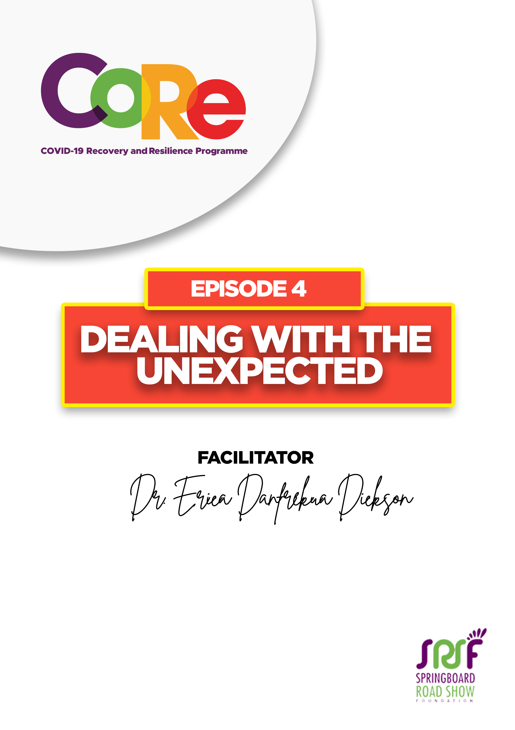
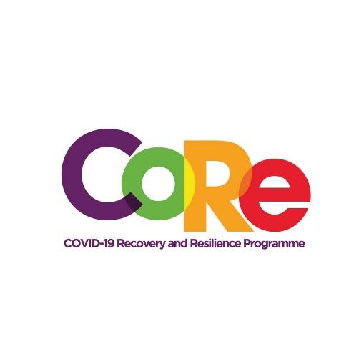
A partnership between




WORKBOOK
This workbook is a personal guide designed to accompany the CoRe Programme’s audio and video lesson for the week. Download it for free on our website www.core.com.gh

- How are you feeling today?
I feel……………………………….
- Excited
- Worried
- Unsure

- How do you assess this year so far?
This year has been………………………
- Great
- Average
- Difficult

- When you compare where you are now to where you thought you would be at the beginning of the year, how would you rate yourself?
I am…………………………………………………
- Ahead
- Behind
- At par

- When you look into the future, how do you feel?
I feel………………………………………………….
- Confident
- Helpless
- Unsure

- Share one positive experience you have encountered this year.
______________________________________________________________
______________________________________________________________

- Share one negative experience you have encountered this year.
______________________________________________________________
______________________________________________________________
- Share one thing you are thankful for this year.
______________________________________________________________

- Which two of the ten ways to deal with the Unexpected will you act on immediately?
- Recognise that changes will definitely come in life
- Do not assume
- Gather enough information
- Look for the positives
- Find something to be grateful for
- Create a positive network of friends
- Stay calm and pause before you act
- Trust in your solutions
- Find creative solutions
- Always keep hope alive

Why?

It is so important to us to hear from you.
- What is the biggest lesson you have learnt from this episode and the workbook?
- What one thing are you determined to do to help you achieve your goals?
- What question would you like to ask the facilitator?
Share your answers to these or any comments you may have on our Facebook Page
https://web.facebook.com/CoReProgramme/, Twitter page https://twitter.com/CoreProgramme or our Instagram Page https://www.instagram.com/coreprogramme/ or on our WhatsApp hotline (+233) 55 153 55 33 and we will respond to you within 24 hours. https://web.facebook.com/CoReProgramme/, Twitter page https://twitter.com/CoreProgramme or our Instagram Page https://www.instagram.com/coreprogramme/ or on our WhatsApp hotline (+233) 55 153 55 33 and we will respond to you within 24 hours.

