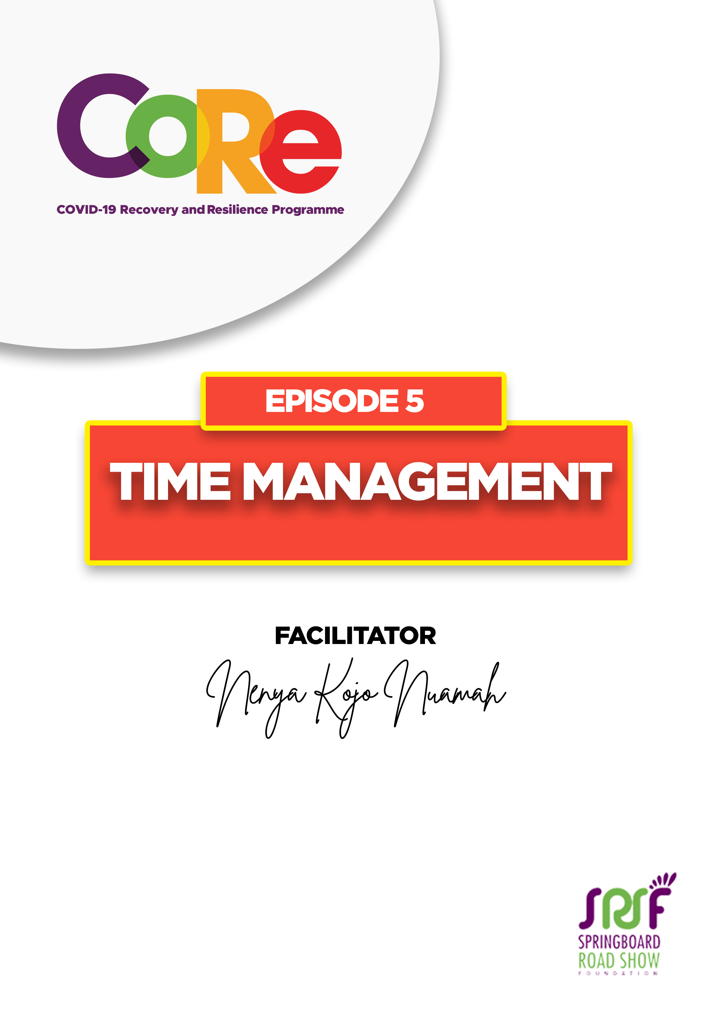
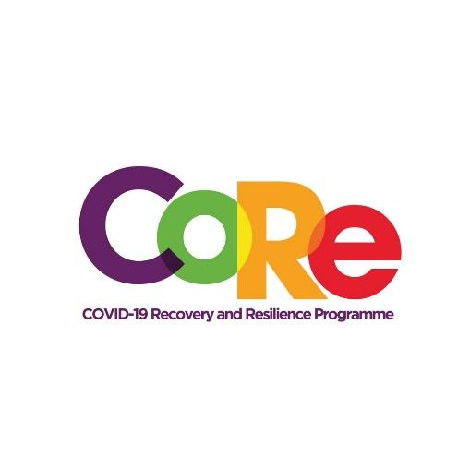



A partnership between

WORKBOOK
This workbook is a personal guide designed to accompany the CoRe Programme’s audio and video lesson for the week. Download it for free on our website www.core.com.gh

- What is the most important item on your plan today?
The most important item on my plan for today is……………………………………………….

- In the table below, list what you planned to do in the first part of today and whether you have achieved them or not.

TIME | ACTIVITY | STATUS
Example:  5am - 6am | Morning devotion and bathing | Achieved
5am-6am
6am-7am
7am-8am
8am-9am
9am-10am
10am-11am
11am-12pm

- Based on your assessment above, how has the first part of today been?
- Very productive
- Quite Productive
- Not productive

Why?

- Comparing today to yesterday, which of the two has been more productive?

_______________________________________________________________________

- What will you do differently if you could restart your day?

___________________________________________________________________

___________________________________________________________________

- Which of these seven steps to effective Time Management is a challenge for you?

- Plan your day before you get out of your bed
- Set clear deadlines
- Set a routine and stick to it
- Decide what can be done at home and what must be done in a particular place.
- Learn what to say ‘no‘ to and what to stop everything to follow
- Always take notes
- Have a “phone time” if you are to make it in business

Why?

- What are you going to do to manage your time more effectively?

_______________________________________________________________________________

_______________________________________________________________________________

8. List 4 habits you need to unlearn this year to make you more productive.

No. | A habit I unlearn this year to make me more productive

It is so important to us to hear from you.
- What is the biggest lesson you have learnt from this episode and the workbook?
- What one thing are you determined to do to help you manage your time effectively and be productive?
- What question would you like to ask the facilitator?
Share your answers to these or any comments you may have on:
Facebook Page: https://web.facebook.com/CoReProgramme/
Twitter Page: https://twitter.com/CoreProgramme
Instagram Page: https://www.instagram.com/coreprogramme/
WhatsApp hotline (+233) 55 153 55 33 and we will respond to you within 24 hours.



