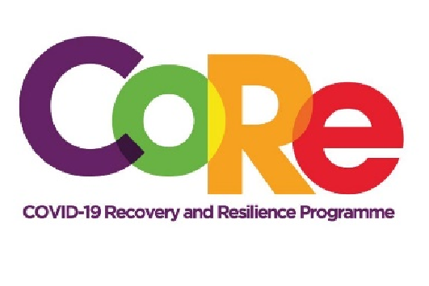
The CoRe Programme
A collaboration between the Springboard Road Show Foundation,
Mastercard Foundation and Solidaridad
WORKBOOK

Episode 1: DISCOVERING YOUR TALENT
Facilitator : Albert Ocran

A talent is simply a God-given or natural ability.

List 4 famous Ghanaians and their talents.

Famous talented Ghanaians | Their talent or skill
Example: Azumah Nelson | Boxing

Make a list of 10 abilities and what you can do with them.
No. | Abilities/Talents | What I can do with them
 | Example: Cooking | Start preparing and packaging lunch for people.
1.
2.
3.
4.
5.
6.
7.
8.
9.
10.
Write a list of 30 things you can easily do and enjoy doing.

1. | 16.
2. | 17.
3. | 18.
4. | 19.
5. | 20.
6. | 21.
7. | 22.
8. | 23.
9. | 24.
10 | 25.
11 | 26.
12 | 27.
13 | 28.
14 | 29.
15 | 30.

Talent Groupings
Based on your list of 30 abilities, count how many of them fall under the groupings below. Example, how many of your abilities fall under sports and physical activities or organizing?
Talent Group Number of Talents

Example: Communication (Written & Verbal) 3

- Communication

- Sports & Physical

- Education, Inspiring people & Research

- Organizing

- Information Technology

- Use of hands

- Entertainment

- Manufacturing, Invention & Hardware

The talent group with the highest score is your main talent. The second and third groups are your supporting talents.

"Your talent is God's great gift to you. What you do with it is your great gift to God." - Leo Buscalgia
We hope you have enjoyed this exercise.
Visit our website www.core.com.gh and follow us on social media
@CoreProgramme for more interesting sessions. For further information call 055 153 55 33

