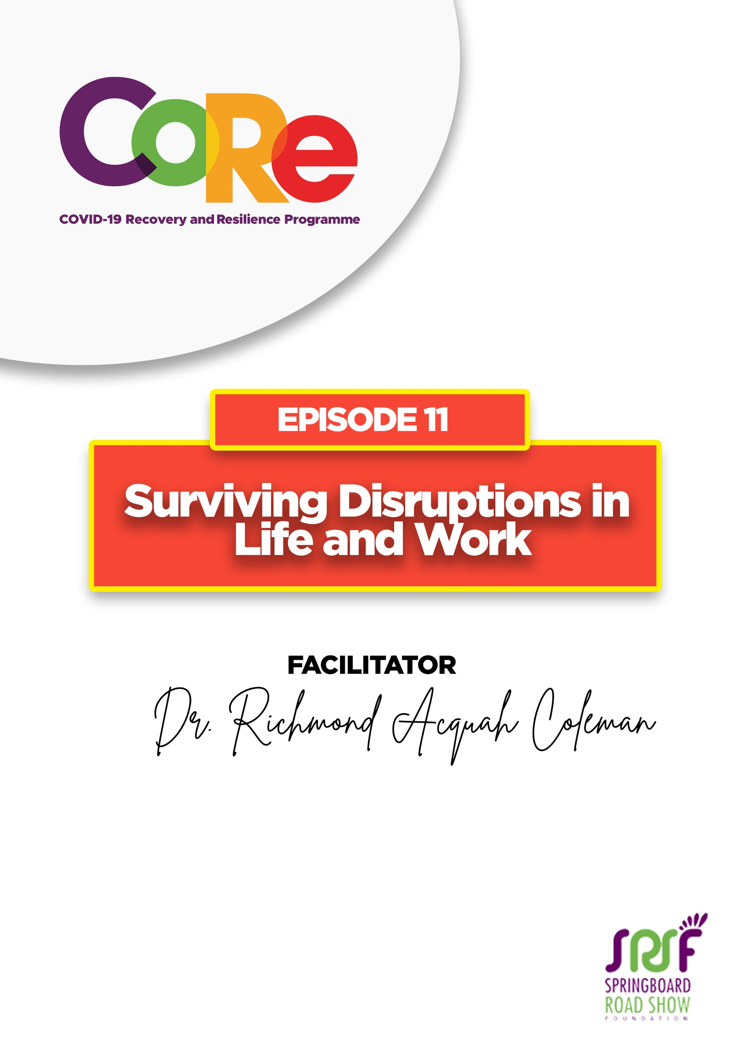
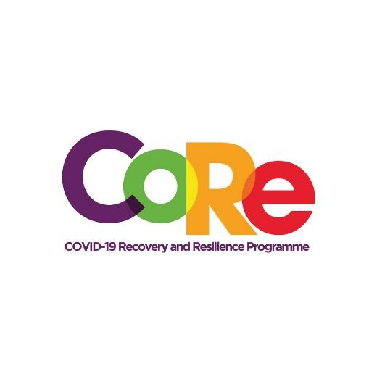




A partnership between

WORKBOOK
This workbook is a personal guide designed to accompany the CoRe Programme’s audio and video lesson for the week. Download it for free on our website www.core.com.gh

Name: _____________________________________________________________________

Phone Number: _____________________________________________________________

Disruptions are events or problems that interrupt an activity or our way of life. For example, when the lights go off in the middle of an evening event, it is a disruption.

Examples of life’s disruptions are:
- COVID-19 pandemic
- Job loss
- Sickness
- Relationship break ups
- Marriage
- Pursuing further education
- Changing career path
- Accepting a new job offer
- Changes in work or the design of work

List two positive and two negative life disruptions you have encountered this year?
No | Positive Life Disruptions | Negative Life Disruptions

Resilience is the process of recovering or adapting well to a life changing situation such as stress, COVID-19 infection, illness, trauma, or tragedy. Resilience consists of behaviors, thoughts and actions that can be learned.

Four Strategies for Building Resilience and Surviving Disruptions
- Build a quality social support system
- Promote good health and well-being
- Be purposeful in your endeavors
- Maintain a positive outlook

To maintain a positive outlook and build resilience, you need to be OPTIMISTIC.

What one thing are you going to do to build your resilience and survive disruptions?
_______________________________________________________________________________

_____________________________________________________________________________

Why? _______________________________________________________________________________

_______________________________________________________________________________

It is so important to us to hear from you.
- What is the biggest lesson you have learnt from this episode and the workbook?
- What one thing are you are going to do help you survive life and work disruptions?
- What question would you like to ask the facilitator?

Share your answers to these or any comments you may have on:
Facebook Page: https://web.facebook.com/CoReProgramme/
Twitter Page: https://twitter.com/CoreProgramme
Instagram Page: https://www.instagram.com/coreprogramme/
WhatsApp hotline (+233) 55 153 55 33 and we will respond to you within 24 hours.



