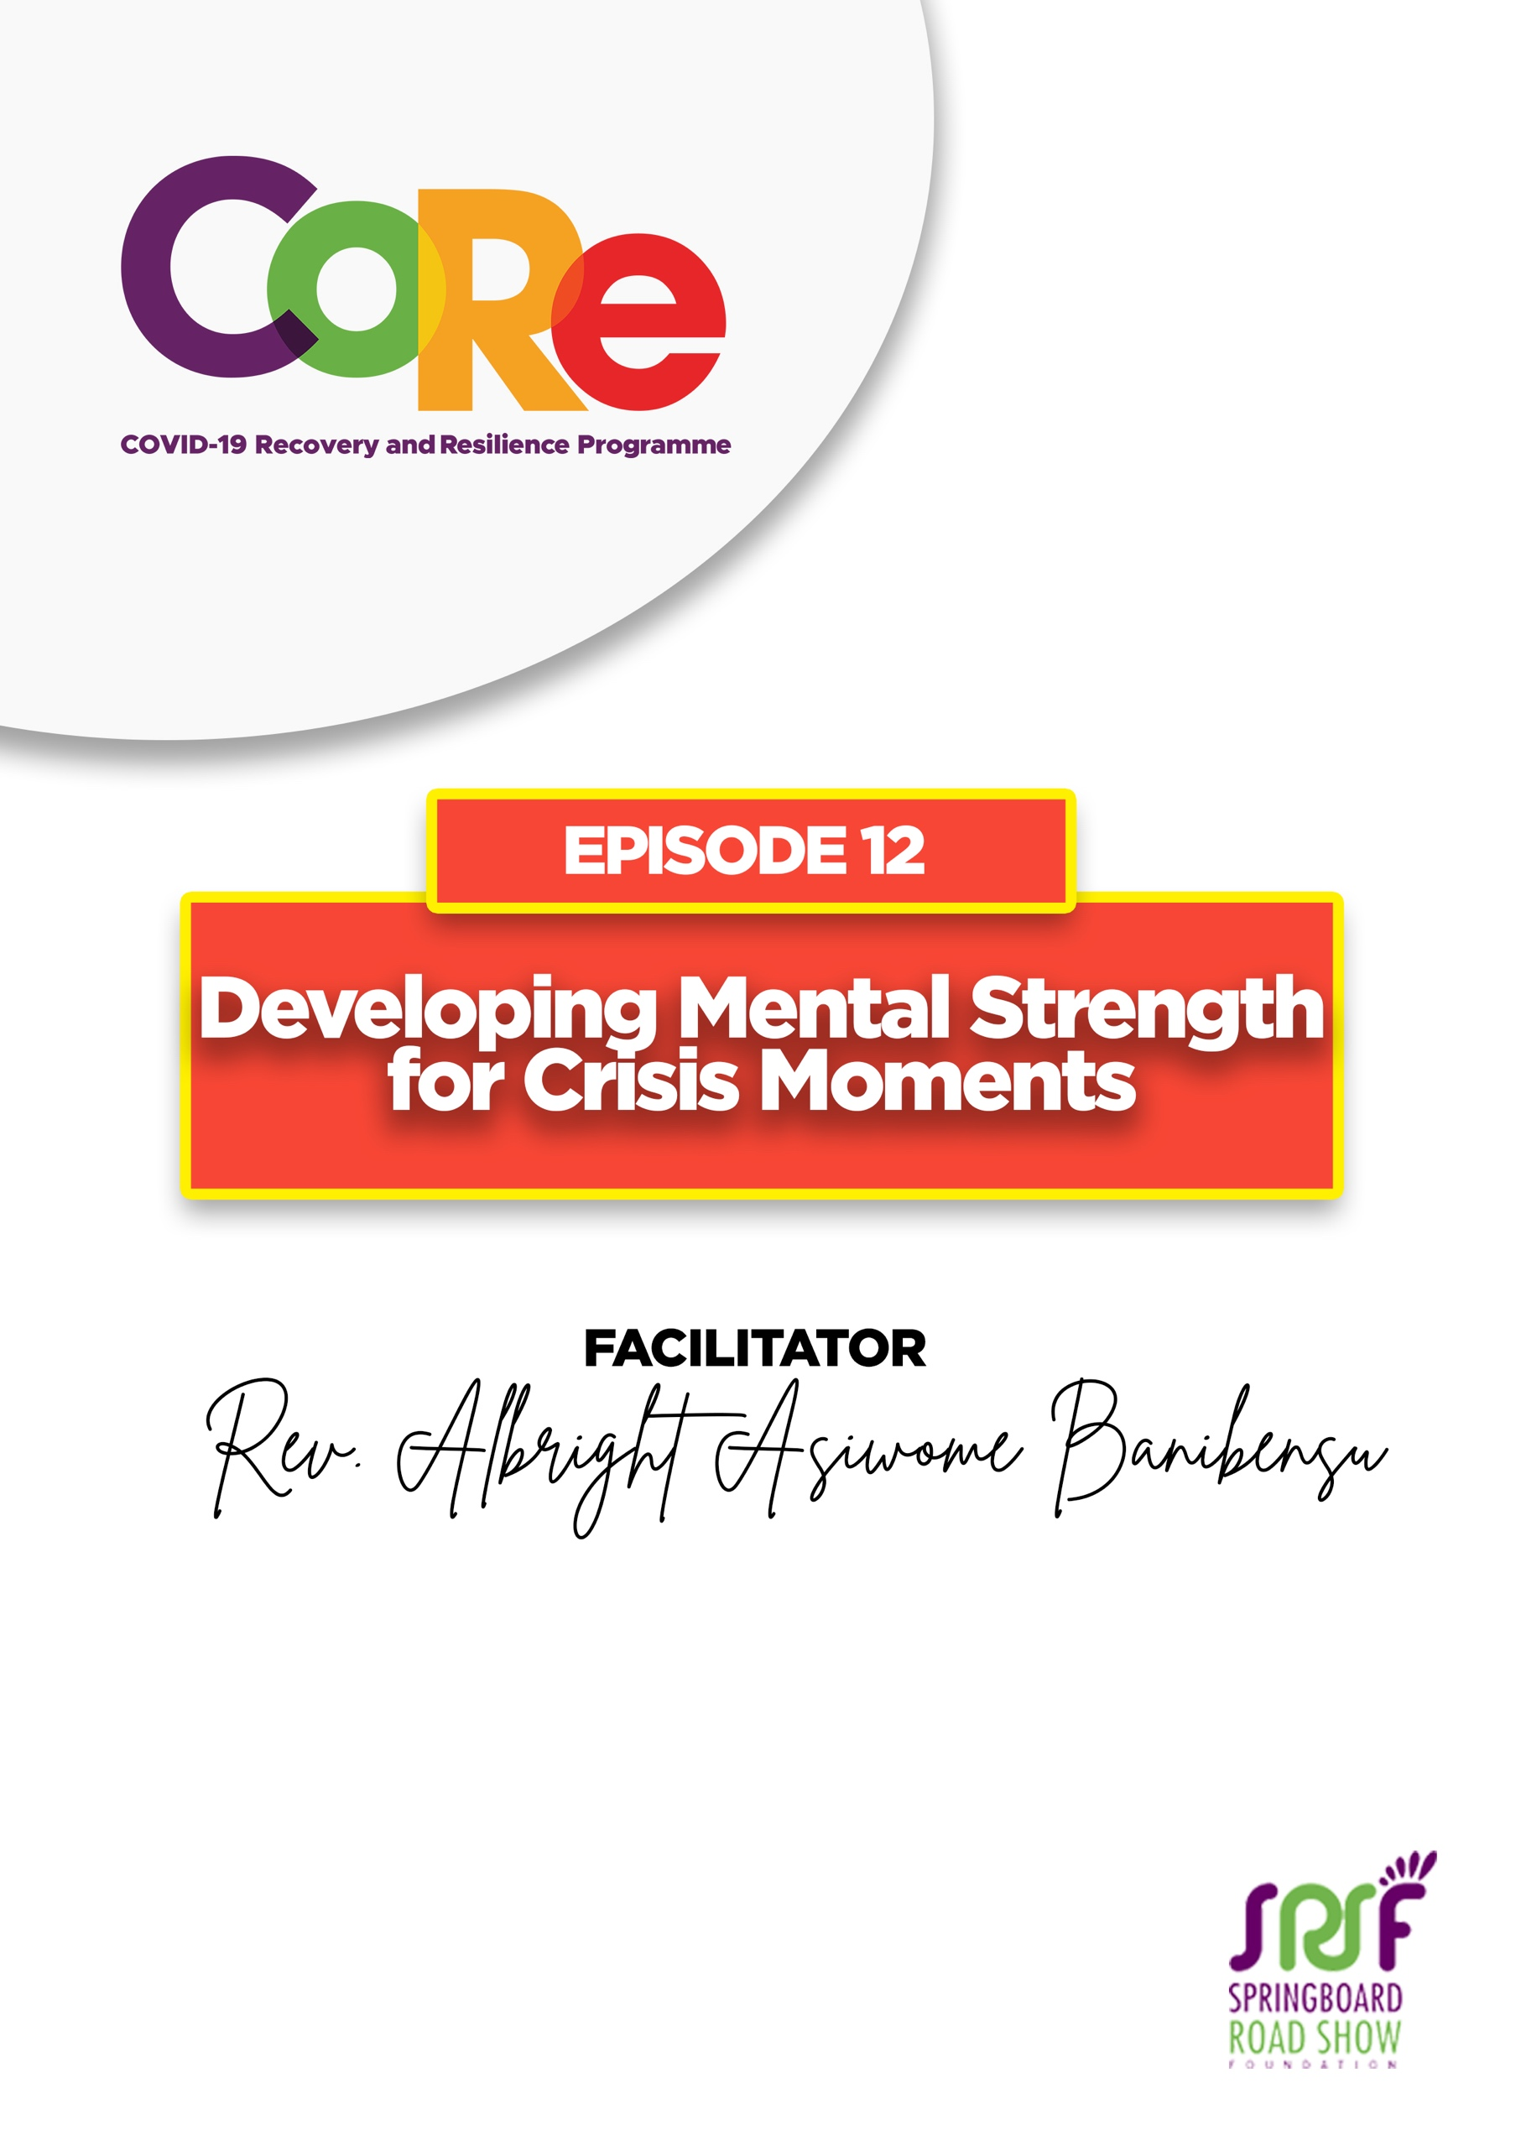
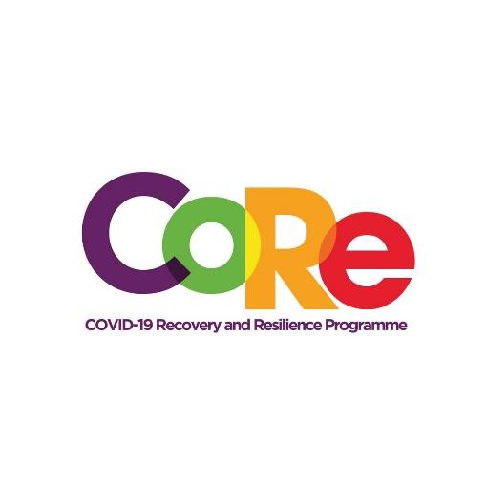




A partnership between

WORKBOOK
This workbook is a personal guide designed to accompany the CoRe Programme’s audio and video lesson for the week. Download it for free on our website www.core.com.gh

Name: _____________________________________________________________________

Phone Number: _____________________________________________________________

A crisis could be defined as a situation or event where a person feels overwhelmed or unable to cope. A typical crisis may include a death in the family, being let go at your job, or a rough ending to a relationship or a pandemic like COVID-19.

A crisis is also a time when a difficult or important decision must be made. To overcome in crisis moments, one needs to develop mental strength or resilience:
- To go through the situation.
- To bounce back.

Resilience is the ability to cope with, adapt to, or bounce back from difficult circumstances.
Coming out of a crisis positively is likely to depend on:
- How much Support we have at the time
- Our previous Experience of distressing events
- Our perceived Capacity to cope with the situation
- The nature and Severity of the situation itself

1. Have you encountered a crisis this year? What happened?
_______________________________________________________________________________
_______________________________________________________________________________
2. What did you do to survive or overcome it?
_______________________________________________________________________________
_______________________________________________________________________________
6 steps to develop your mental strength by Brother Albright
- Accept that crisis is part of life
- Know what you genuinely want.
- Surround yourself with amazing people
- Avoid the victim mentality
- Recount your past achievements
- Visualise the end from the beginning

3. Which of the above steps, will you use to build your mental strength? Why?
_______________________________________________________________________________
_______________________________________________________________________________
_______________________________________________________________________________

4. Think of two people that you can call on to discuss any challenges you are facing.
(Write down their names.)

A. _______________________________________________________________________________
B. _______________________________________________________________________________
When was the last time you spoke with or spent time with any of these two people?
(You probably should call them right after this or as soon as practicable)

5. List three unpleasant things that happened in your life, which you later found to be blessings in disguise.

A. _______________________________________________________________________________
B. _______________________________________________________________________________
C. _______________________________________________________________________________

6. Write down three things you have achieved over the past two years that you are really proud of yourself for.

A. _______________________________________________________________________________
B. _______________________________________________________________________________
C. _______________________________________________________________________________

CLOSING EXERCISE
- Close your eyes.
- Think of the future you wanted to have.
- Imagine that you have achieved everything you needed to achieve.
- Think about this achievement for a minute.

Let us to hear from you.
- What is the biggest lesson you have learnt from this episode and the workbook?
- What will you do with the lesson you just learnt?
- What question would you like to ask the facilitator?

Share your answers to these or any comments you may have on:
Facebook Page: https://web.facebook.com/CoReProgramme/
Twitter Page: https://twitter.com/CoreProgramme
Instagram Page: https://www.instagram.com/coreprogramme/

WhatsApp hotline (+233) 55 153 55 33 and we will respond to you within 24 hours.

