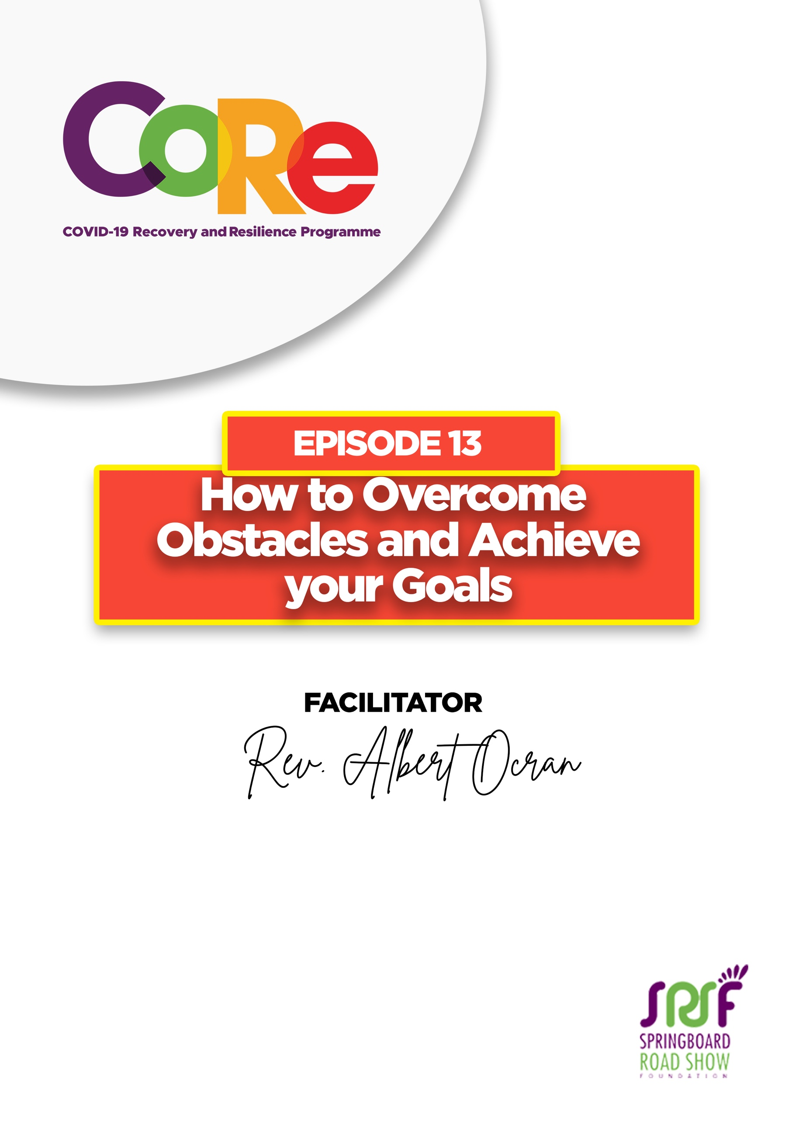
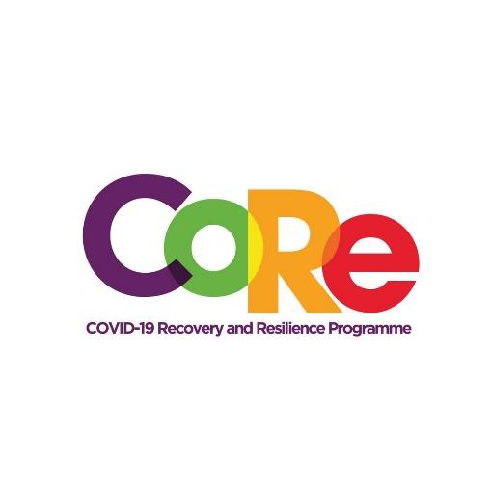

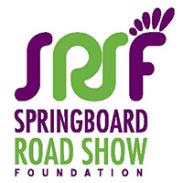
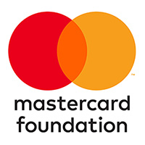

A partnership between

WORKBOOK
This workbook is a personal guide designed to accompany the CoRe Programme’s audio and video lesson for the week. Download it for free on our website www.core.com.gh

Name: _____________________________________________________________________

Phone Number: _____________________________________________________________

A Goal is ‘an aim, a desire or a roadmap to a particular destination.’ Many people set their goals for the year at the beginning of the year. Your goals could be spiritual, professional, financial, social or physical.
An Obstacle is as anything that hinders, prevents or blocks you from progressing or achieving your goals or targets.
Goals are Roadmaps while Obstacles are Roadblocks.
5 Benefits of Goals are;
- They give a Clear Direction about what you want to achieve;
- Goals help in Decision making and keep you Focused;
- Goals keep you motivated and inspired;
- Goals give you a sense of satisfaction;
- Goals provide a basis for measurement.

- What are your two biggest goals for this year?
________________________________________________________________________
________________________________________________________________________

- Have you encountered any obstacle (s) in trying to achieve your goals? Were they financial, health or legal obstacles? Write them down.

Lessons from the Akoko and Akroma Story
Lessons from the Hen (Akoko)
- Her strategy was not flexible.
- There was poor teamwork.
- The hen’s team did not communicate.
Lessons from the Hawk (Akroma)
- Akroma had a flexible strategy.
- It was patient in its work.
- It was responsive to changes around it.
- It seized the opportunity (the chicken) with speed.

- What one thing will you do to be less like the hen (Akoko)?
________________________________________________________________________
________________________________________________________________________

- What one thing will you do to be more like the hawk (Akroma)?
________________________________________________________________________
________________________________________________________________________

Let us to hear from you.
- What is the biggest lesson you have learnt from this episode and the workbook?
- What will you do with the lesson you just learnt?
- What question would you like to ask the facilitator?

Share your answers to these or any comments you may have on:
Facebook Page: https://web.facebook.com/CoReProgramme/
Twitter Page: https://twitter.com/CoreProgramme
Instagram Page: https://www.instagram.com/coreprogramme/
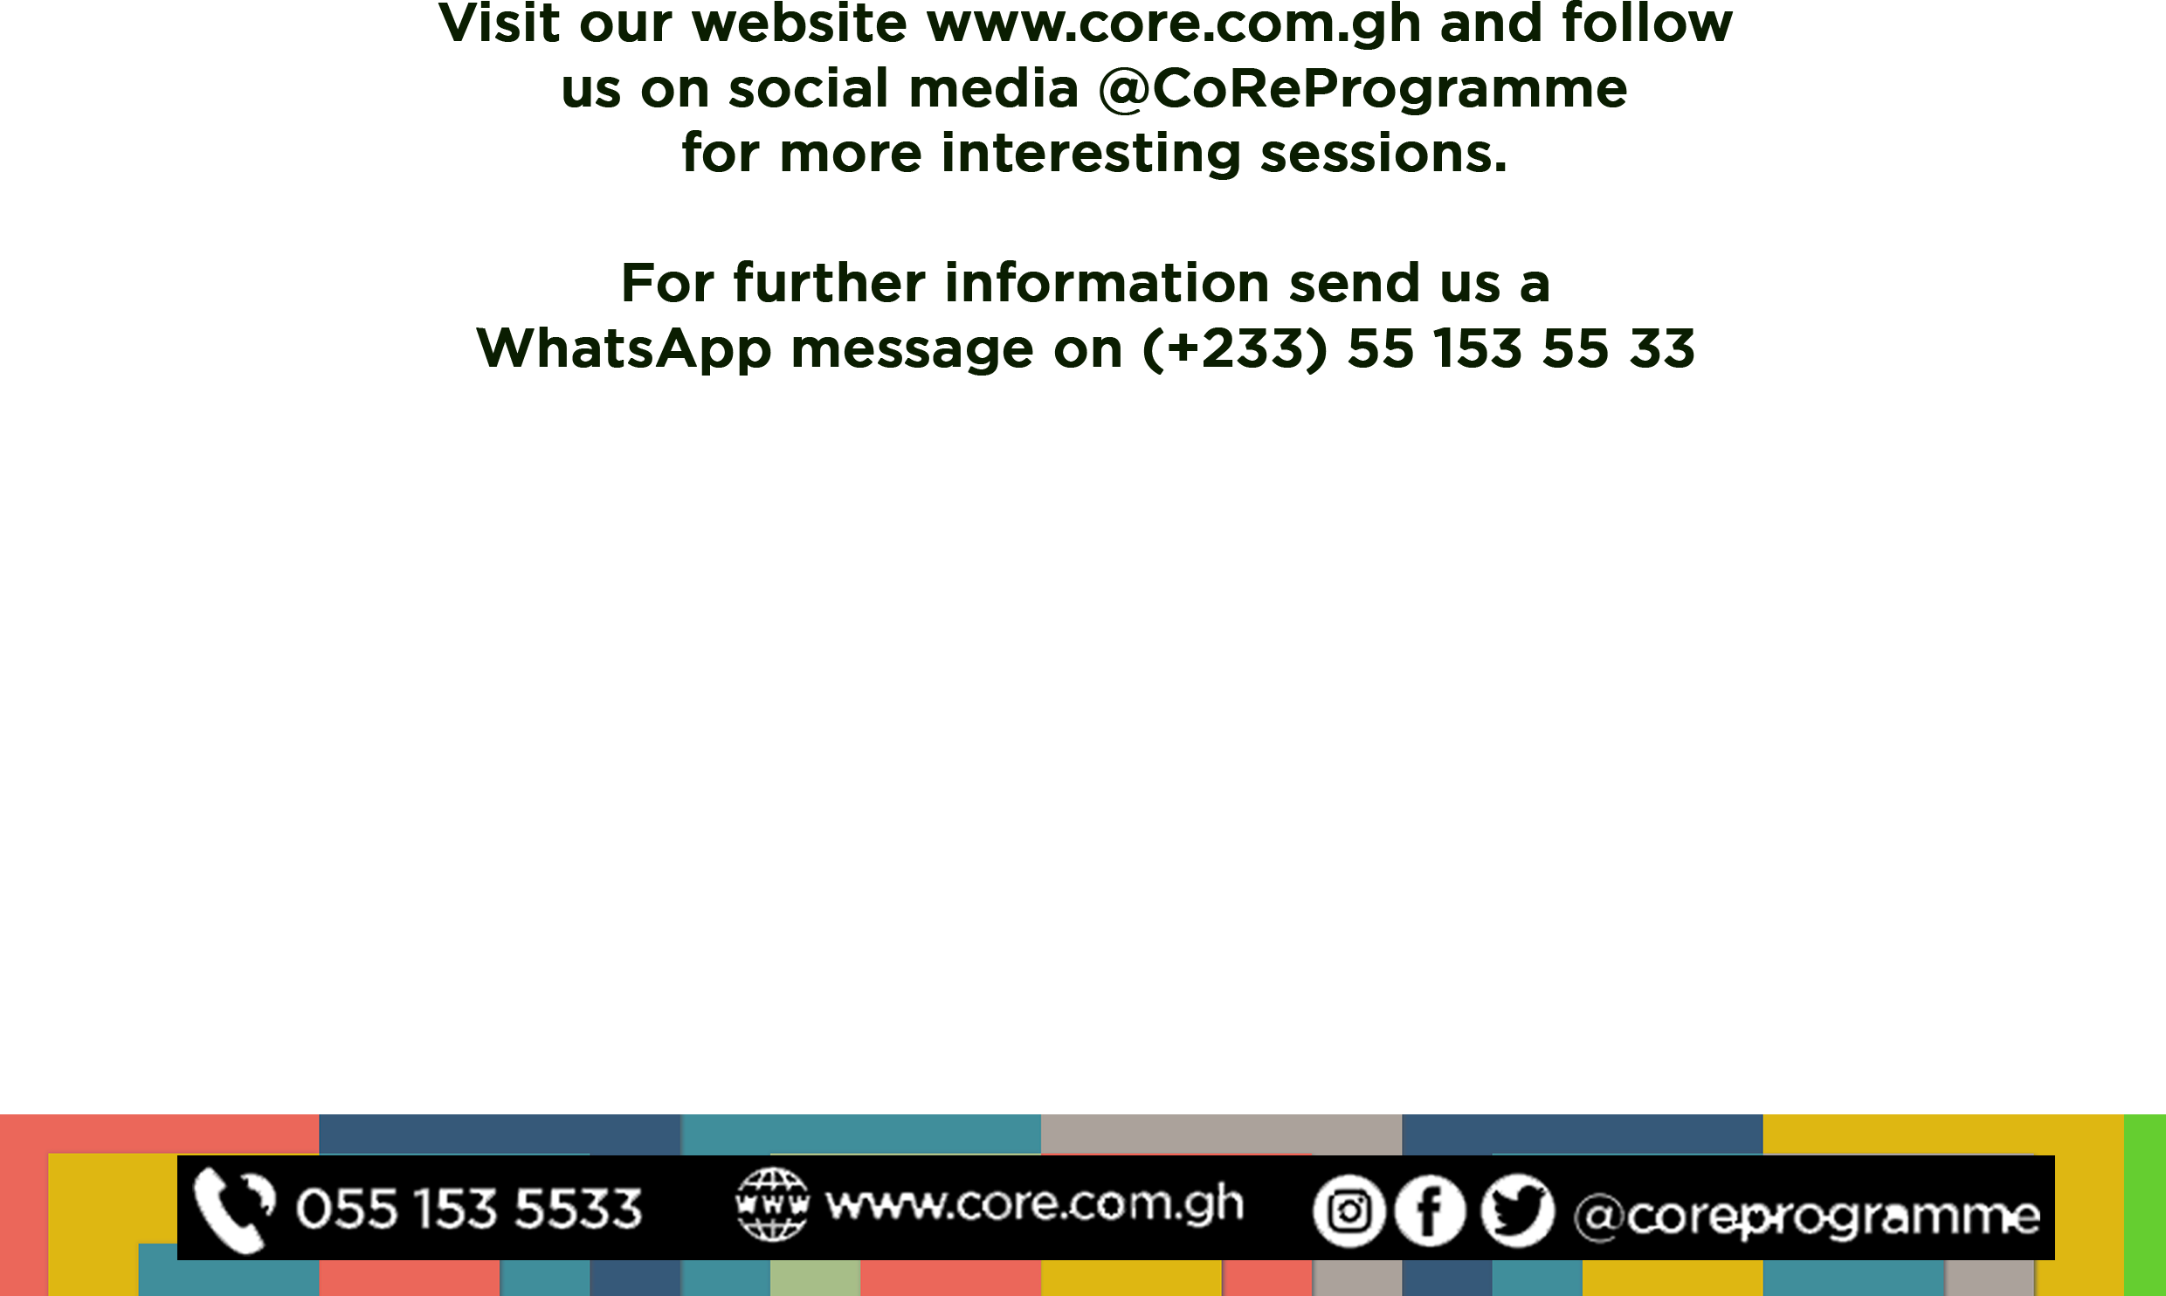
WhatsApp hotline (+233) 55 153 55 33 and we will respond to you within 24 hours.

