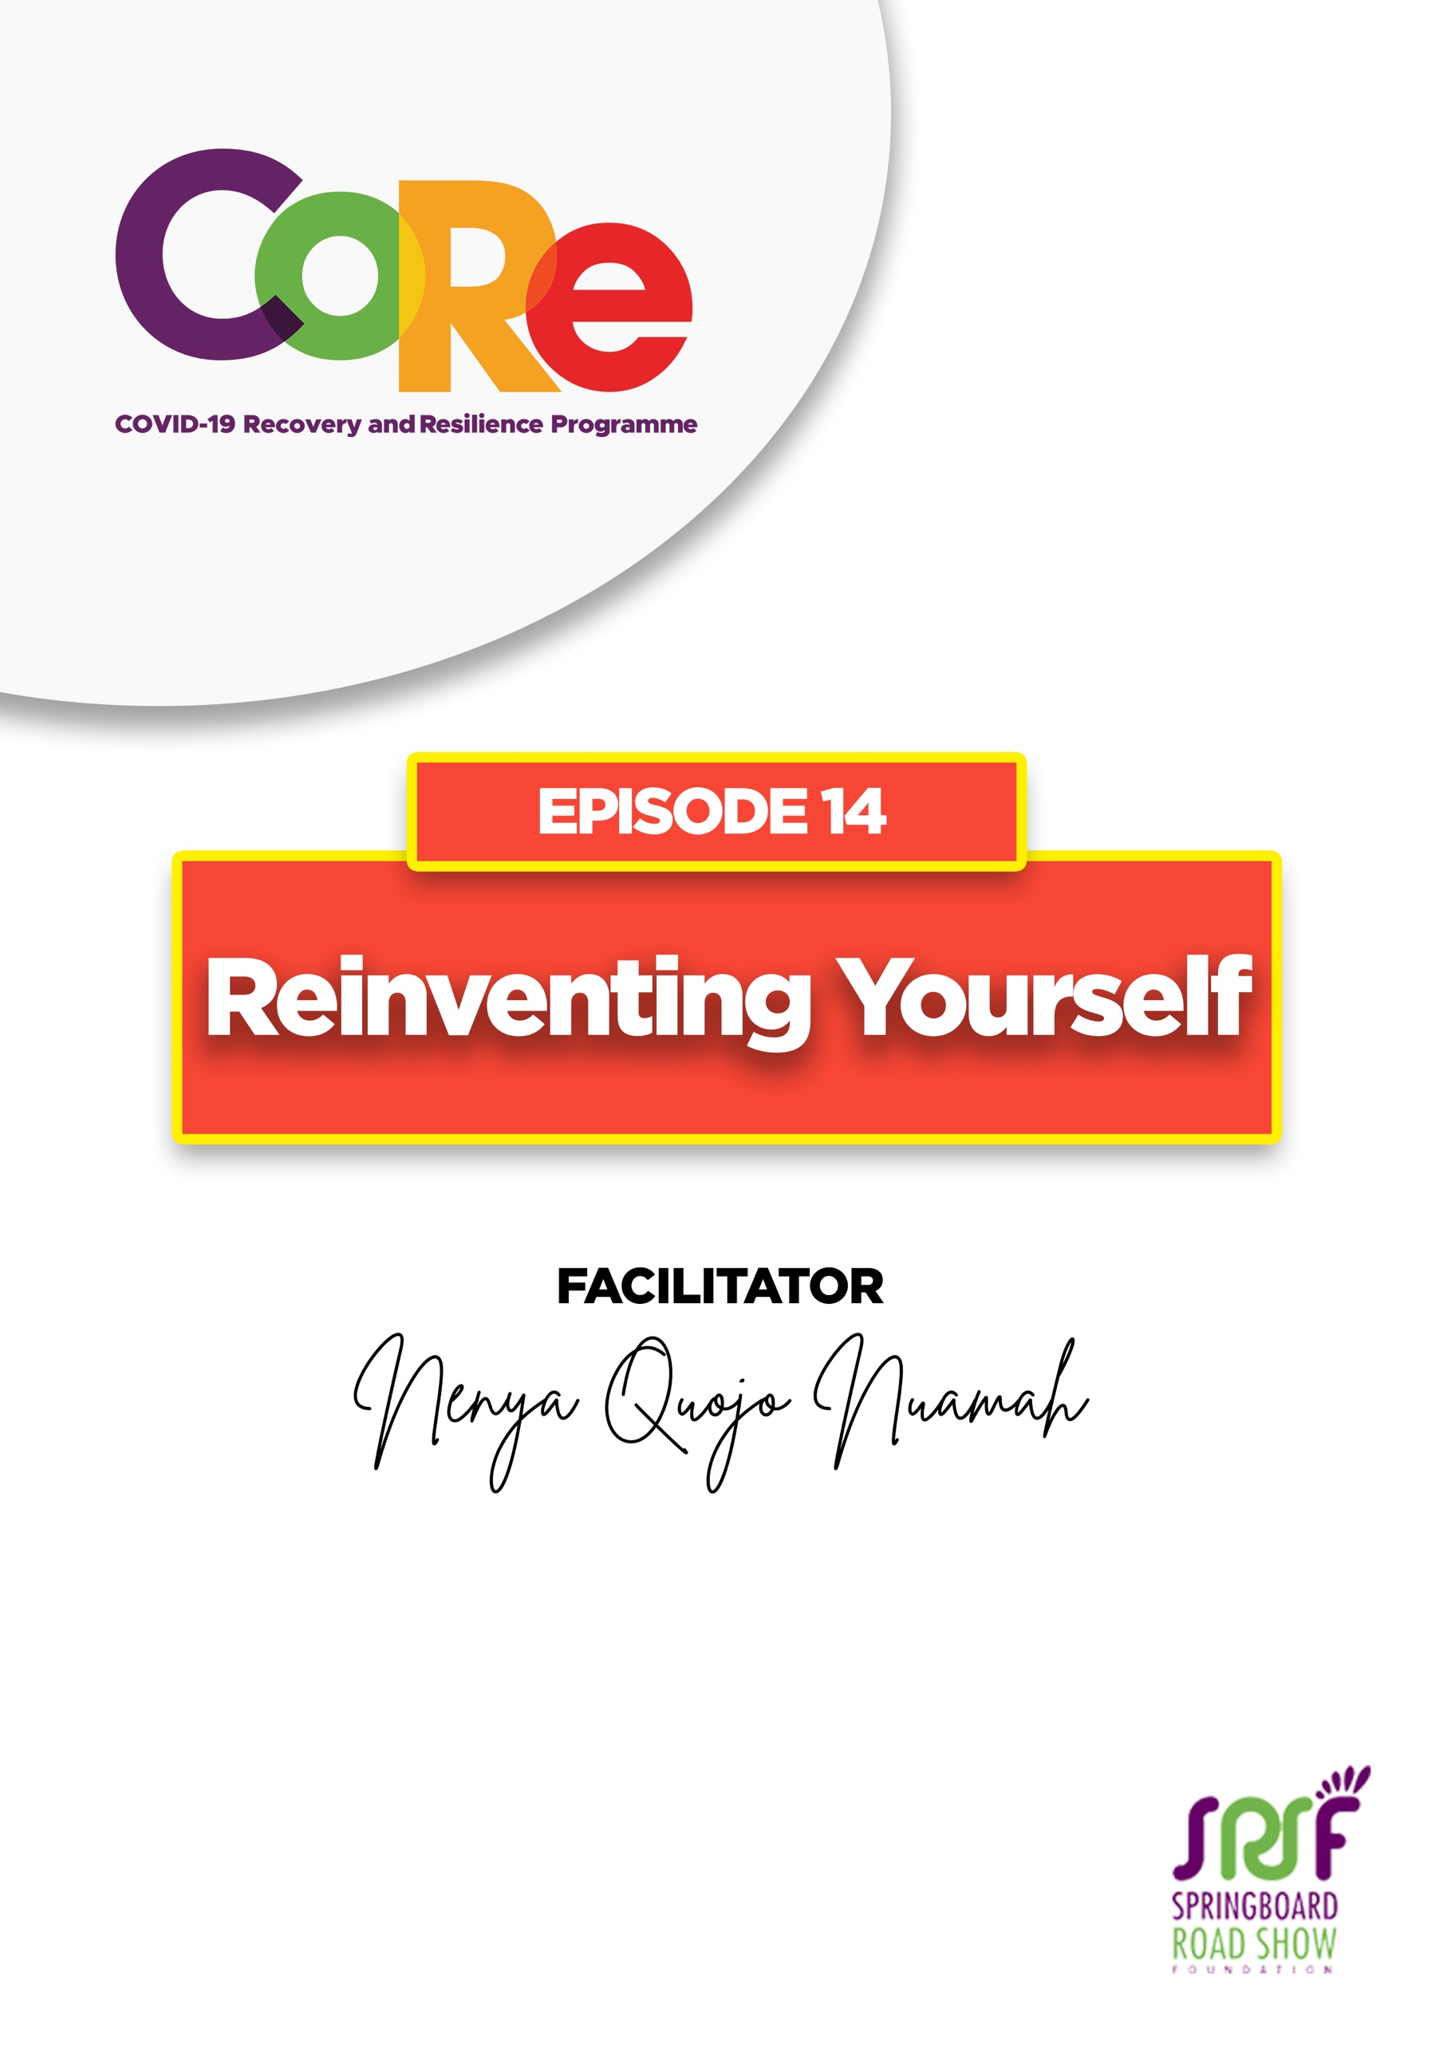
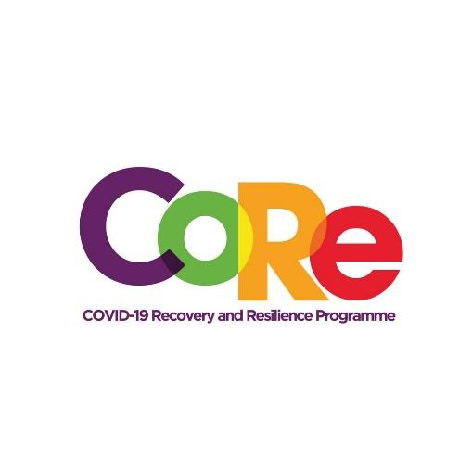




A partnership between

WORKBOOK
This workbook is a personal guide designed to accompany the CoRe Programme’s audio and video lesson for the week. Download it for free on our website www.core.com.gh

Name: _____________________________________________________________________

Phone Number: _____________________________________________________________

Reinventing yourself means “to move away from an old situation to a new situation.” Reinventing yourself could be; changing your spending habit, staying away from unprofitable company/ friends or deciding to live and eat healthier.

Share 1 old habit you are going to unlearn and 1 new habit you would like to pick up.

Old Habit: ________________________________________________________________________

New Habit: ________________________________________________________________________

Eight tips for reinventing yourself by Nenya Quojo Nuamah
- Start the day right.
- Decide what habits you must unlearn
- Decide which new skills to acquire
- Find coaches or mentors
- Beware of self-sabotage
- Connect Digitally
- Pray Always
- Understand Money

Write down three things you would do if you were not afraid you will fail.
- ___________________________________________________________________

- ___________________________________________________________________

- ___________________________________________________________________

Which one of the three things above would you do immediately? Why?
________________________________________________________________________

________________________________________________________________________

Let us to hear from you.
- What is the biggest lesson you have learnt from this episode and the workbook?
- What will you do with the lesson you just learnt?
- What question would you like to ask the facilitator?

Share your answers to these or any comments you may have on:
Facebook Page: https://web.facebook.com/CoReProgramme/
Twitter Page: https://twitter.com/CoreProgramme
Instagram Page: https://www.instagram.com/coreprogramme/

WhatsApp hotline (+233) 55 153 55 33 and we will respond to you within 24 hours.

