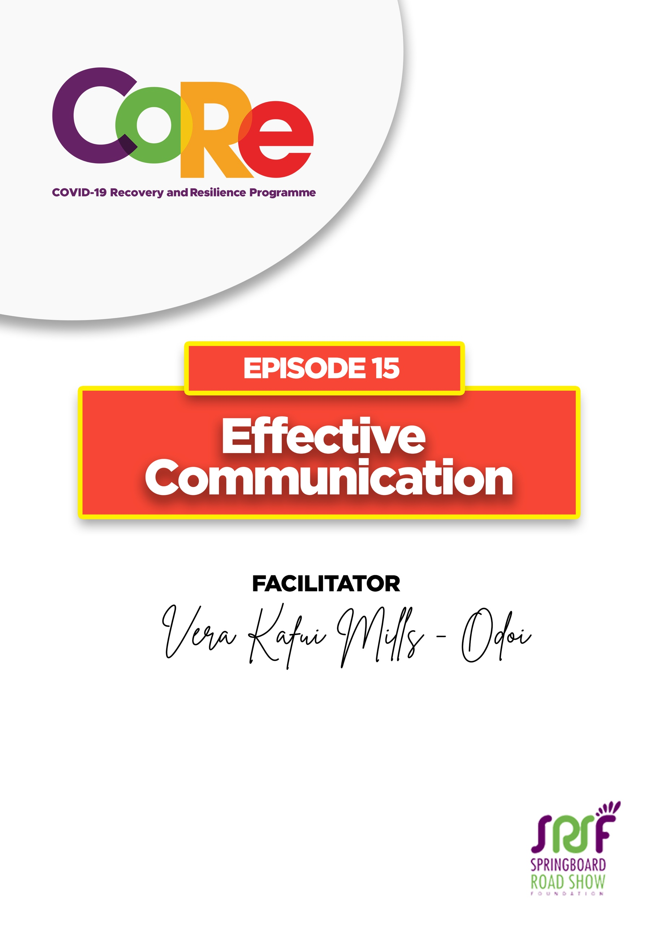
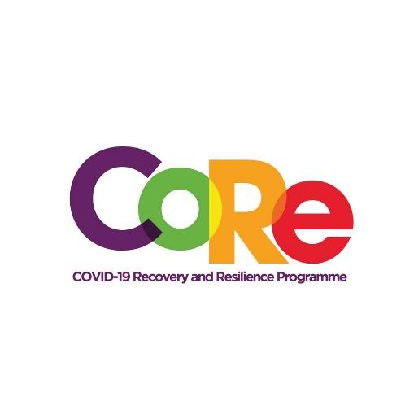


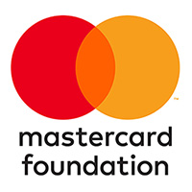

A partnership between

WORKBOOK
This workbook is a personal guide designed to accompany the CoRe Programme’s audio and video lesson for the week. Download it for free on our website www.core.com.gh

Name: _____________________________________________________________________

Phone Number: _____________________________________________________________

According to dictionary.com, COMMUNICATION is the imparting or interchange of thoughts, opinions, or information by speech, writing, or signs. The Oxford Learner’s Dictionary also defines it as the activity or process of expressing ideas and feelings or of giving people information.

Effective Communication is producing successful results through the expression of ideas from a SENDER to a RECEIVER using the appropriate MEDIA.

Forms of Communication
- Verbal Communication: Speaking directly with other people either face-to-face or through channels such as telephone, Zoom etc.
- Non-Verbal Communication: The things we do when we are speaking or communicating. This can include hand movement, facial expressions, posture, eye contact etc.

Communication involves three components:
- The SENDER
- The CHANNEL through which it is being done and
- The RECEIVER.

CHANNELS of communication are mediums through which information is shared with people. Some of these channels are face-to-face interaction, phones, email, WhatsApp, social media, Zoom, etc.

What are your top three channels of communicating with people?

- ________________________________________________________________

- ________________________________________________________________

- ________________________________________________________________

A BARRIER is anything that can distort your message or hinder a receiver from understanding your message. It could be noise, overuse of words, language, etc.

What barrier have you identified in your communication?

- ________________________________________________________________

- ________________________________________________________________

- ________________________________________________________________

An AUDIENCE is the target receiver of your message. They receive, interpret, and share feedback on the message you share with them. The audience could be your customer, work colleague, school mate, etc.

What three changes will you make to improve your communication with your audience?

- ________________________________________________________________

- ________________________________________________________________

- ________________________________________________________________

Let us to hear from you.
- What is the biggest lesson you have learnt from this episode and the workbook?
- What will you do with the lesson you just learnt?
- What question would you like to ask the facilitator?

Share your answers to these or any comments you may have on:
Facebook Page: https://web.facebook.com/CoReProgramme/
Twitter Page: https://twitter.com/CoreProgramme
Instagram Page: https://www.instagram.com/coreprogramme/
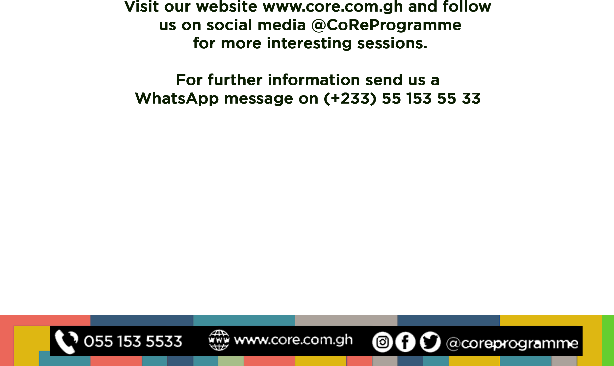
WhatsApp hotline (+233) 55 153 55 33 and we will respond to you within 24 hours.

