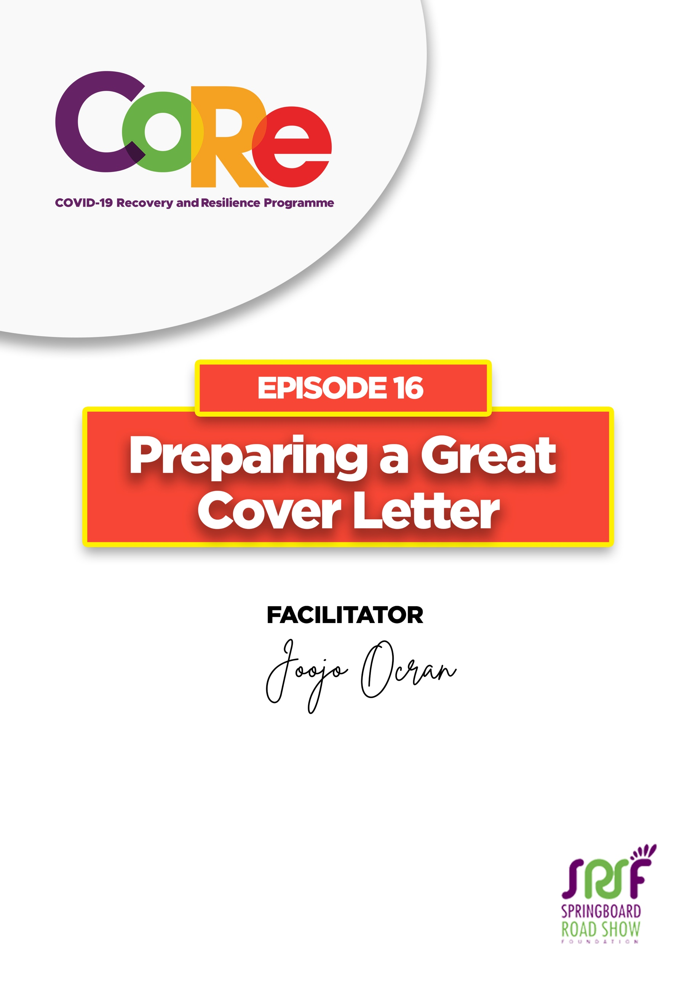
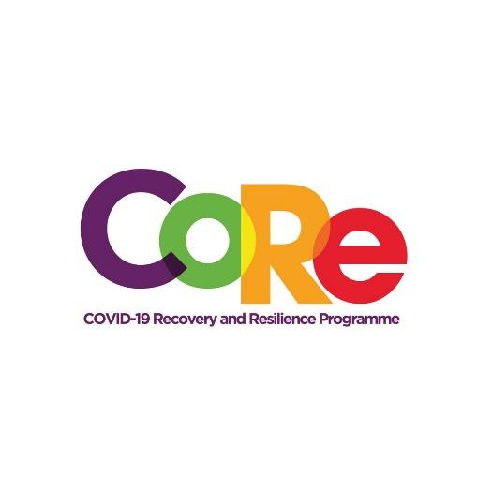


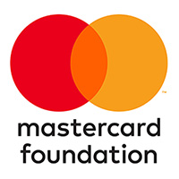
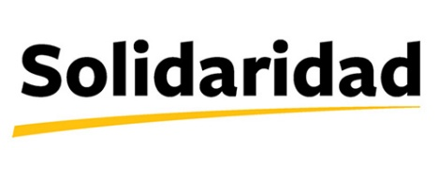
A partnership between

WORKBOOK
This workbook is a personal guide designed to accompany the CoRe Programme’s audio and video lesson for the week. Download it for free on our website www.core.com.gh

Name: _____________________________________________________________________

Phone Number: _____________________________________________________________

A Cover Letter is a written document that is submitted with a job application outlining the applicant's qualifications and interest in an open position

Importance of Cover Letters

- Increases your chances of getting one noticed
- It increases your chance of standing out to your potential employer because you can give more context on the skills and experiences you have had.

Six main parts of a Cover Letter

- Header/ Contact Details: It includes your contact details such as your Name, Phone Number, Email, etc. which helps the reviewer, or the recruiter know you. Avoid using unprofessional email addresses like: SexyDavid@yahoo.com

- Salutation: That is where you introduce yourself and let the reviewer know who you are

- Opening Paragraph: This is where the “six seconds” comes into play. Your opening paragraph is where you kind of need to hook your reader

- Body: This your main section for your main discussion points. Talk about why you are the perfect candidate for the job, the unique skills that you bring to the table, the experiences that you bring to the table, etc.

- Closing Paragraph: This is where you need to sum up everything you have said and, you know. Close strong and then finally go formal salutation.

Dos and Don’ts of Cover Letters
- Make your experience and skills clear
- Focus on the job description: It gives you everything you will need to write the ideal cover letter
- Do not make it all about yourself
- Do not use generic templates, it makes your cover letter boring
- Avoid clutter and cliché: Try to keep it concise because at the end of the day, your cover letter should not be longer than one page.

Top tips for writing a great cover letter

- Articulate your achievements and your accomplishments in a way that fits on a page, but still conveys the breadth and depth of what you have been able to accomplish so far in your career and why that is relevant for the company.
- Research- This is one of the places that really help you stand out from other applicants
- Use templates right- Templates have already been developed, customize them for each company that you are working with
- Dive deep- Review your cover letter multiple times to catch any errors mistakes or anything that could potentially put you out of contention and have someone else reread it as well.

Share two new things you have learned about Cover Letter

Let us hear from you.
- What is the biggest lesson you have learnt from this episode and the workbook?
- What will you do with the lesson you just learnt?
- What question would you like to ask the facilitator?

Share your answers to these or any comments you may have on:
Facebook Page: https://web.facebook.com/CoReProgramme/
Twitter Page: https://twitter.com/CoreProgramme
Instagram Page: https://www.instagram.com/coreprogramme/
WhatsApp hotline (+233) 55 153 55 33 and we will respond to you within 24 hours.
