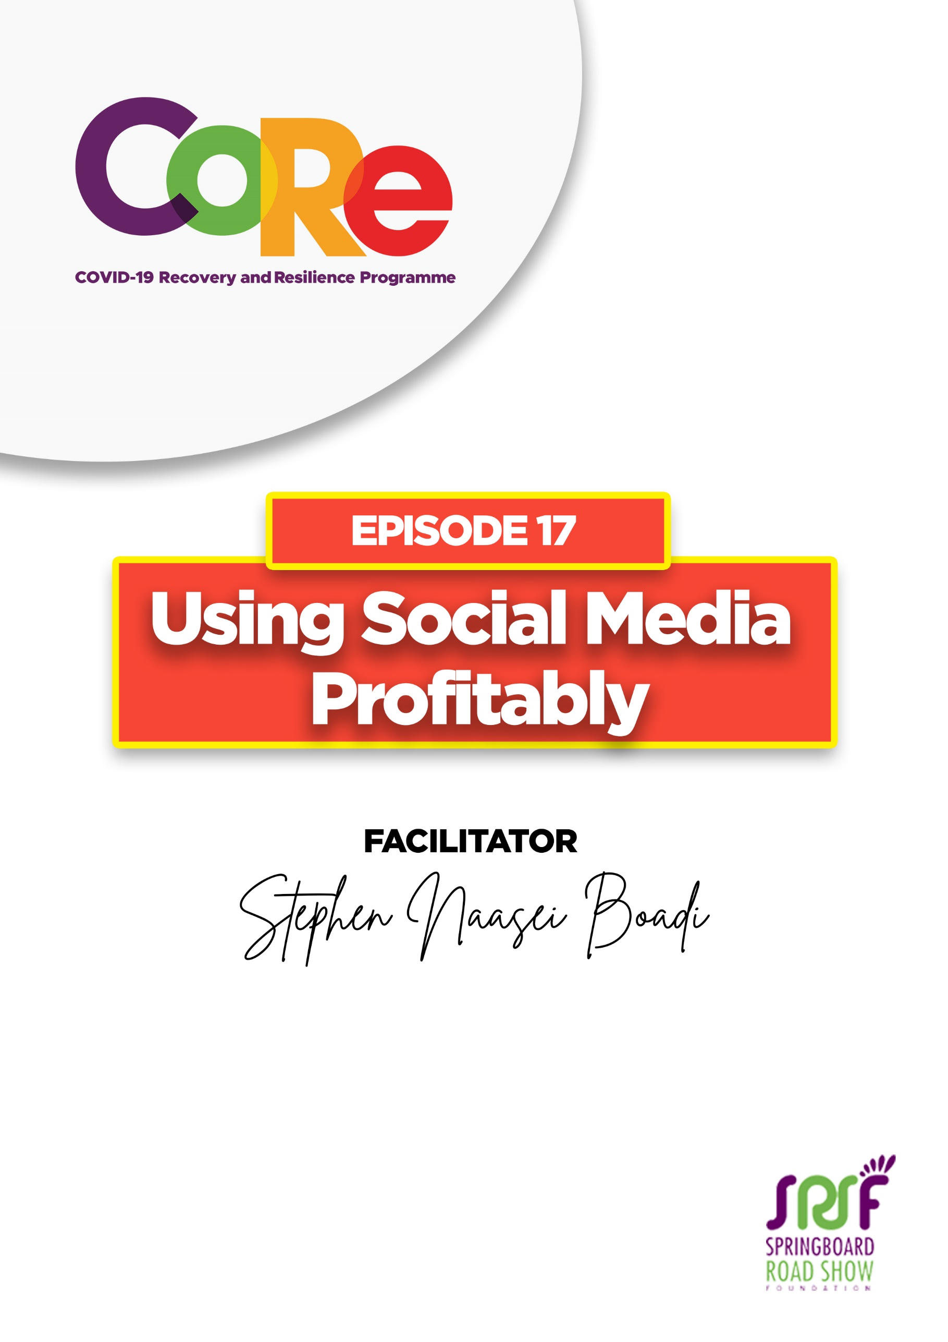
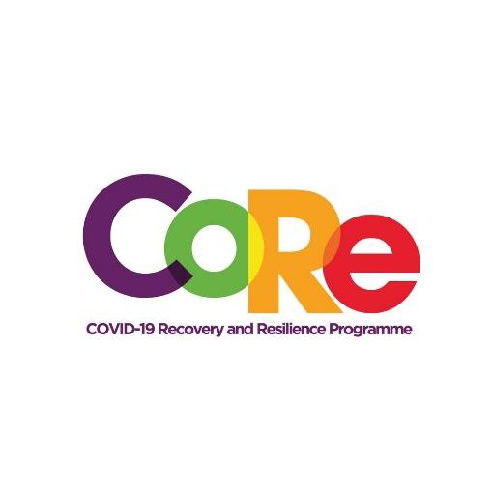




A partnership between

WORKBOOK
This workbook is a personal guide designed to accompany the CoRe Programme’s audio and video lesson for the week. Download it for free on our website www.core.com.gh

Name: _____________________________________________________________________

Phone Number: _____________________________________________________________

Social Media refers to websites and applications that enable users to create and share content or to participate in social networking. They also enable us to be able to network with other people who are online. Social Media apps include WhatsApp, Facebook messenger, Telegram, Instagram, and other ones.

- List the top five social media networks or applications that you know of.

________________________________________________________________________

________________________________________________________________________

________________________________________________________________________

________________________________________________________________________

________________________________________________________________________

- How many of them do you use regularly?

________________________________________________________________________

- How many of them do your friends and family use regularly?

________________________________________________________________________

Most Used Social Media Platforms in Ghana

Using Social Media to Promote Your Business

Social media can be used profitably to grow your business if there is a strategy driving it.

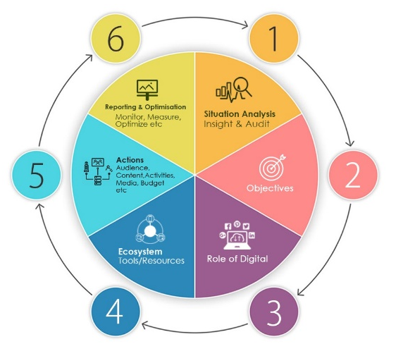
SODEAR Model

Situation Analysis: Where are you (PESTEL, Insights, Audit etc.)?
Objectives: What do you want to achieve?
Role of Digital: What should be the role of Digital (Social Media)
Ecosystem: Which online and online platforms should be used and how should they be integrated? Create your platforms and build the community/recruit fans and followers.
Actions: What are the specific actions to be taken (campaigns, always-on etc.)
Reporting & Optimization: How will you Monitor, Measure and Optimize performance?

Content Strategy refers to the planning, development, and management of content. It's your content that gets people to know you. Your content must Lead to a conversation, Generate enquiry and Lead to business.

Your content should be Useful, Relevant, Disruptive, Shareable, and Entertaining, and it should be packaged in the right format.

Content Pillars

Products/Services: Drive awareness of your products/services

Campaigns: Ensure your product/services are top of mind of your customers. Be the go-to person if they need a product/service you offer

Peer to Peer: Content about your product/service must be shareable. It must be easy to be shared by your followers.

Expert Advice: Offer expert tips on how your product/service can be used or be beneficial to your customers

Social media is paid to play, meaning it is not free. Set aside a budget that you would use to promote whatever you are doing.

Making Money as YouTuber
- YouTube is the biggest video sharing platform in the world, number 3 most active Social Media platform in Ghana
- You can make money as a YouTuber by being paid by YouTube through its AdSense scheme or by brands for the content you create.
- To be successful:
  - Create your channel
  - Create relevant content and focus on subject matter you are familiar with (food, travel, technology, parenting etc.)
  - Increase your subscriber base
  - Increase your video views

Making Money as a Social Media Influencer
- Brands are always looking for individuals to help tell their story.
- Social Media Influencers are people (celebrity or everyday people) who have a strong online presence and following, and are able to influence the choices, interests and preferences of their followers.
- To make money as a social media influencer:
  - Create your online presence
  - Create relevant content and focus on subject matter you are familiar with (food, travel, technology, parenting etc.)
  - Increase your fanbase
  - Learn about your followers and their interests
  - Learn about brands and brand building
  - Build lasting relationships with brand owners
  - Increase your engagement

Helpful Tips for using Social Media Profitably by Stephen Naasei Boadi
- Everything is real time and on steroids, be ready to cope with the pace
- Everyone is a publisher, listen and participate in conversation, Social Listening
- Trolling is real
- Don’t make Social Media an IT thing
- Don’t focus on the technology alone. Focus on the functionality, with consideration of the customer needs and user experience
- Align your social media objectives with overall business/organisation objectives
- Don’t chase Likes and other Vanity Metric
- Don’t do tactical execution without strategy
- Don’t spam people – WhatsApp, Messenger, Telegram, etc.
- Don’t replace traditional marketing with social media; think, plan and execute integrated
- Don’t go Live without clear objectives, look for success and a strategy to monitor, measure and optimize
- Set content Pillars
- Have a mix of campaign and always-on activities
- Don’t equate Celebrity with Influencer Power

- From this episode, what one thing are you going to do differently to make your Social Media profitable to you.

________________________________________________________________________

________________________________________________________________________

________________________________________________________________________

Let us hear from you.
- What is the biggest lesson you have learnt from this episode and the workbook?
- What will you do with the lesson you just learnt?
- What question would you like to ask the facilitator?

Share your answers to these or any comments you may have on:
Facebook Page: https://web.facebook.com/CoReProgramme/
Twitter Page: https://twitter.com/CoreProgramme
Instagram Page: https://www.instagram.com/coreprogramme/
WhatsApp hotline (+233) 55 153 55 33 and we will respond to you within 24 hours.
