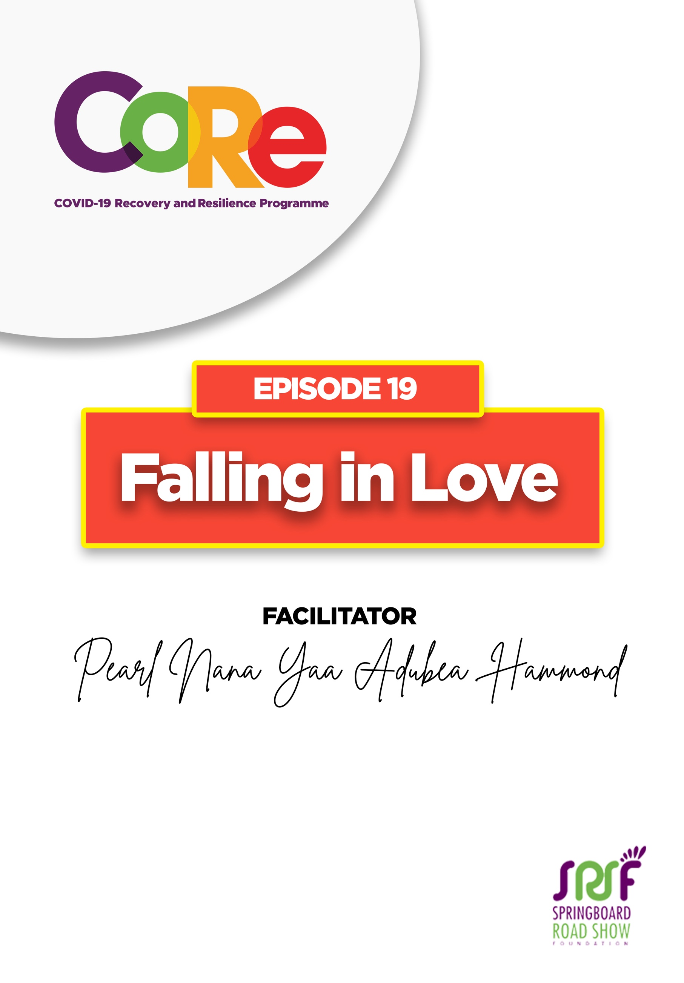
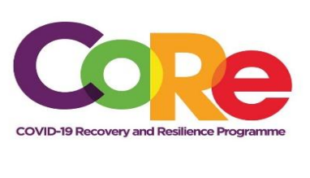


A partnership between



WORKBOOK
This workbook is a personal guide designed to accompany the CoRe Programme’s audio and video lesson for the week. Download it for free on our website www.core.com.gh

Name: _____________________________________________________________________

Phone Number: _____________________________________________________________

Love is the feeling that a person has for another person. It means to be deeply committed and connected to someone or something in such a way that it usually ends in a permanent commitment known as marriage.

- Have you ever fallen in love? How did it feel like?

________________________________________________________________________

________________________________________________________________________

________________________________________________________________________

- Have you heard of love at first sight? Have you experienced it? Share your experience with us.

Falling in love is one of the most exciting and rewarding things you can ever do. Everyone experiences love at different times in their own unique ways. Falling in love can lead to marriage. Marriage is God's idea and not man's idea.

- How do you know you are in love with the right person?

_______________________________________________________________________________

Tips on identifying that you are in love with the right person by Pearl Nana Yaa Adubea Hammond
- You are happy - When you are in love with the right person, you are happy
- Everything feels new and exciting - When you are in love with the right person, you are excited to do the things you have already done a million times before, because it is with your partner and no other person.
- Your relationship feels easy - when you are in love, you don't struggle to find time to spend with your partner because you really want to. Everyday apart really feels like forever.
- The person is always on your mind - When you are in love, your partner is always at the back of your mind.
- You can get a little jealous - A little bit of jealousy is natural, but it becomes dangerous when you start getting obsessed over what your partner is doing.
- You become more affectionate towards them - When you are in love, you are obviously attracted to your partner.
- You want to bring them around your family and friends - When you are really into your relationship you want to bring your partner into all aspects of your life.
- You start feeling a sense of empathy towards your partner - When you are in love, you start seeing your partner as an extension of yourself.
- You become a better person - You know, you are in love when being with your partner makes you want to improve yourself.
- You start planning for the future together - When you truly love someone, you start including them in your future plans.

There are three main kinds of love; Agape Love which is a selfless love, Phileo Love which is a brotherly love and Eros Love which is a romantic love.

The best relationships are built on agape. It is the foundation upon which the others are built. Love is never wasted for its value does not rest upon reciprocity. You can choose to make your relationship work or choose to destroy it. It all depends on you and your partner.

Exercise
Close your eyes and think of all the good things that you want to happen in your life together with your partner. Tell us how this brief exercise made you feel.

T. Tolis says “to love is nothing, to be loved is something, but to love and to be loved, that's everything”

Let us hear from you.
- What is the biggest lesson you have learnt from this episode and the workbook?
- What will you do with the lesson you just learnt?
- What question would you like to ask the facilitator?

Share your answers to these or any comments you may have on:
Facebook Page: https://web.facebook.com/CoReProgramme/
Twitter Page: https://twitter.com/CoreProgramme
Instagram Page: https://www.instagram.com/coreprogramme/
WhatsApp hotline (+233) 55 153 55 33 and we will respond to you within 24 hours.


