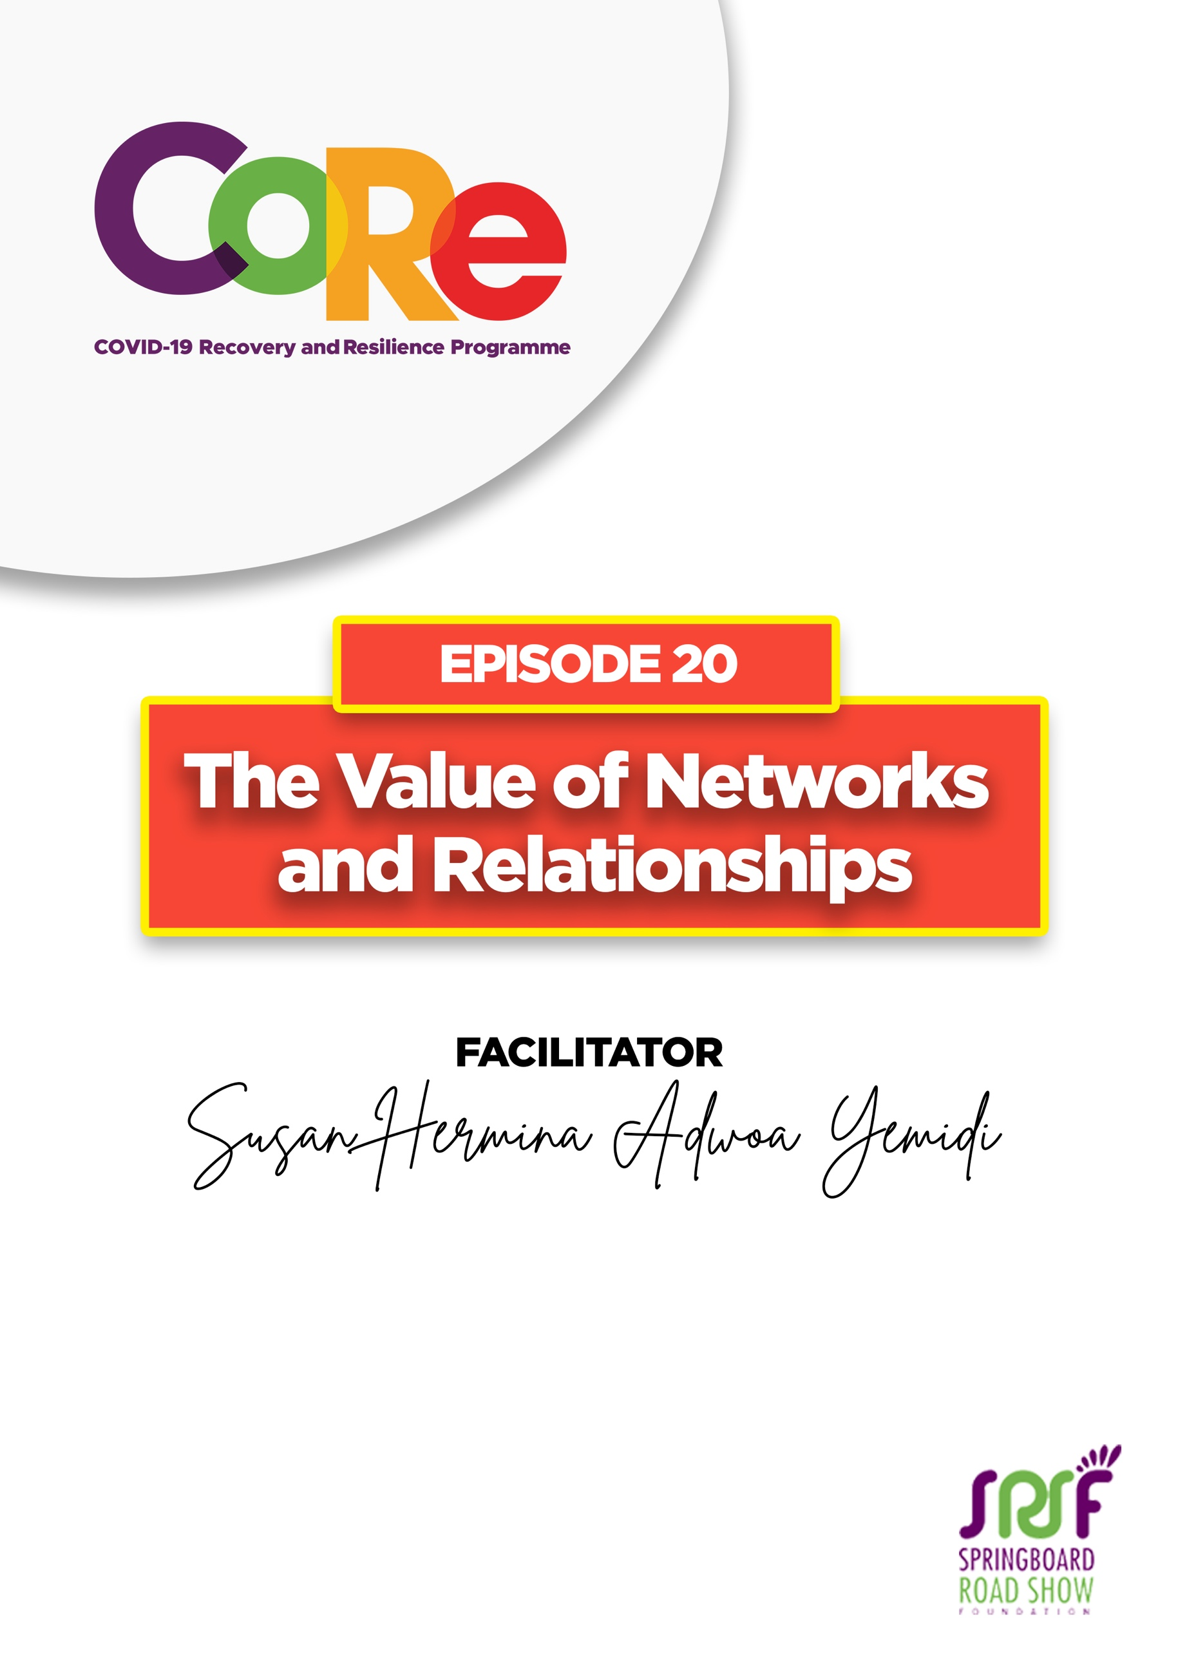
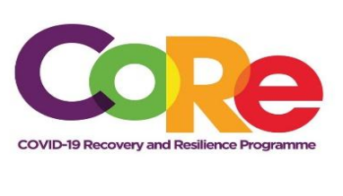


A partnership between



WORKBOOK
This workbook is a personal guide designed to accompany the CoRe Programme’s audio and video lesson for the week. Download it for free on our website www.core.com.gh

Name: _____________________________________________________________________

Phone Number: _____________________________________________________________

Relationships are connections that we have with people. These people could be members of our families, our colleagues or from social circles, such as our churches and other groups we belong to. They are close to us, know us, and understand us.

Networks are the interactions we have with people who are not necessarily strongly associated with us.

Our relationships and networks are very important; they should therefore be strong, profitable and beneficial.

Do you have a network?

- How did it come about?

Why we need to build networks and relationships

- Relationships and networks cushion us in difficult times in life and help us to achieve our goals.
- Professionally, relationships help you get Guidance, Mentoring and Coaching. As a student, the relationships that you build will support you academically.
- Relationships and networks also provide us with a platform to learn and to teach, it is a two-way street.
- Relationships and networks provide us with a sense of belonging. No one is an island, and we need relationships to provide support in our times of need.
- Builds trust: people would always find you dependable and reliable and would also reciprocate in the same manner. It is also important not to be judgmental of people as we are all different people with different attitudes, behaviors, beliefs, et cetera.
- Alignment with your Purpose: When your purpose is aligned with the people in your space, they profit you and promote your goals.

How to build and maintain strong relationships and networks

- Be friendly if you want to be connected with people. The way we interact with our siblings at home, the way we interact with our colleagues at work, at church and at other social gatherings should be friendly enough to establish good connections.
- Always ask questions and give feedback. When we are with our friends, families or acquaintances, we should ask questions and give them feedback. That way, we build relationships that enable us to move on with the agenda that we have for our lives.
- Share relevant information about your thoughts, ideas, visions, hopes and aspirations. When we interact this way, when we give and take, we build deeper bonds.
- Be open in your relationships: We maintain our networks by giving open and honest feedback by building trust.
- Invest in your relationships and networks: When invitations are given, look at the invitations and if they are coming from people who are key and relevant to you, this is when you decide that you need to really also honor those invitations.
- Be intentional and deliberate: Build relationships that would propel you to achieve your vision, achieve your aspirations, and helps you achieve our goals.

What is your favourite lesson from today’s episode?

________________________________________________________________________

________________________________________________________________________

Based on what you’ve learned, what will you do to improve your networks and relationships?

Let us hear from you.
- What is the biggest lesson you have learnt from this episode and the workbook?
- What will you do with the lesson you just learnt?
- What question would you like to ask the facilitator?

Share your answers to these or any comments you may have on:
Facebook Page: https://web.facebook.com/CoReProgramme/
Twitter Page: https://twitter.com/CoreProgramme
Instagram Page: https://www.instagram.com/coreprogramme/
WhatsApp hotline (+233) 55 153 55 33 and we will respond to you within 24 hours.


