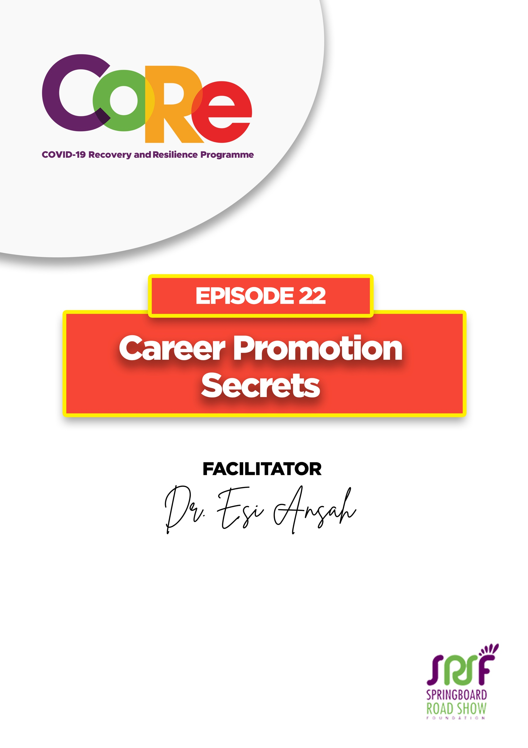
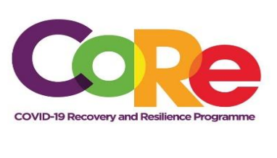


A partnership between



WORKBOOK
This workbook is a personal guide designed to accompany the CoRe Programme’s audio and video lesson for the week. Download it for free on our website www.core.com.gh

Name: _____________________________________________________________________

Phone Number: _____________________________________________________________

Career is an occupation undertaken for a significant period of a person's life and with opportunities for progress.

Career Promotion takes place when an employee moves higher in the ranked levels within an organization. It allows an employee to progress to a higher position, a higher level of responsibility and higher levels of authority within the organization.

One of the things that is important, regardless of whether you are working, whether you are in school, or whether you are in waiting, is learning more about your career interest.
To learn about your career interest, you must read relevant materials about your interests. There are so many resources online, if you go to a website like Wikihow (part of Wikipedia) you can learn about anything, how to make things, how to create, how to fix, everything is on there.
One other way in which you can read widely and learn more about your career interests is finding resources such as books or sometimes a programme on radio.

What do you do while you are waiting, that will help you to advance your career?

Recruiters look at three key things from the people they hire, they are;
Head: This is what you know, it is important as they want to know that you are coming in with some knowledge.
Hands: This is what you can do with your mind. What is it that you can do? What are the tools that you can use?
Heart: Recruiters look for who you are, your attitude towards work, your work ethic, etc. to know that you have the knowledge they are looking for. They want to know if you have the actual skills that they are looking for, meaning you can do the work they are giving to you. And then it is important for them to know who you are as a person.

While you are in waiting before you find a job, or even when you are in a job, it is important to build yourself in these three areas.
- Build your tangible skills by learning how to use a toolset or a toolkit like Microsoft office.
- An Apprenticeship can help build your skills through finding somebody who does what you are interested in, learning from the person, and going in with the attitude and the mindset to learn.
- Volunteering is another option to build your skills. Volunteer to work for people to help you gain skills you would need when you get a job.
- Online Programmes: There are websites where you can sign up for courses and learn. You can use your phones to download a lot of apps for learning. And once you do this, by the time a job opportunity opens, you would have prepared yourself adequately.
Soft skills are especially important as you improve and build yourself and get ready to find the ideal job. Three key soft skills that are must-haves are:
Be proactive: Every employer wants to hire somebody who is proactive. Being proactive means that you do not sit down, fold your arms, and wait for somebody to tell you what to do. Instead, you identify ways where you can do things better.
Be versatile: Be versatile by being flexible and being able to do different things. You tend to have different skills, and you can move into different roles, learn new things, do different things as you build your career.
Excellence: Make sure that whatever you are doing, is done with excellence. Excellence is what makes you different and sets you apart from everybody else. Anything you do, make sure you do it well, and when you do that, it can make people recommend you.

What do you do while you are in waiting?

If you are now trying to decide what career you are even interested in, ask yourself these three questions using the acronym SIP: Strengths, Interests, Purpose.
S - What are my strengths?
I - What are my interests?
P - What is my purpose?

And then, what are your actual skills, the skills you have that you can use to work on your SIPS.

What do you do to build your experience once you get onto the job?

Let us hear from you.
- What is the biggest lesson you have learnt from this episode and the workbook?
- What will you do with the lesson you just learnt?
- What question would you like to ask the facilitator?

Share your answers to these or any comments you may have on:
Facebook Page: https://web.facebook.com/CoReProgramme/
Twitter Page: https://twitter.com/CoreProgramme
Instagram Page: https://www.instagram.com/coreprogramme/
WhatsApp hotline (+233) 55 153 55 33 and we will respond to you within 24 hours.
