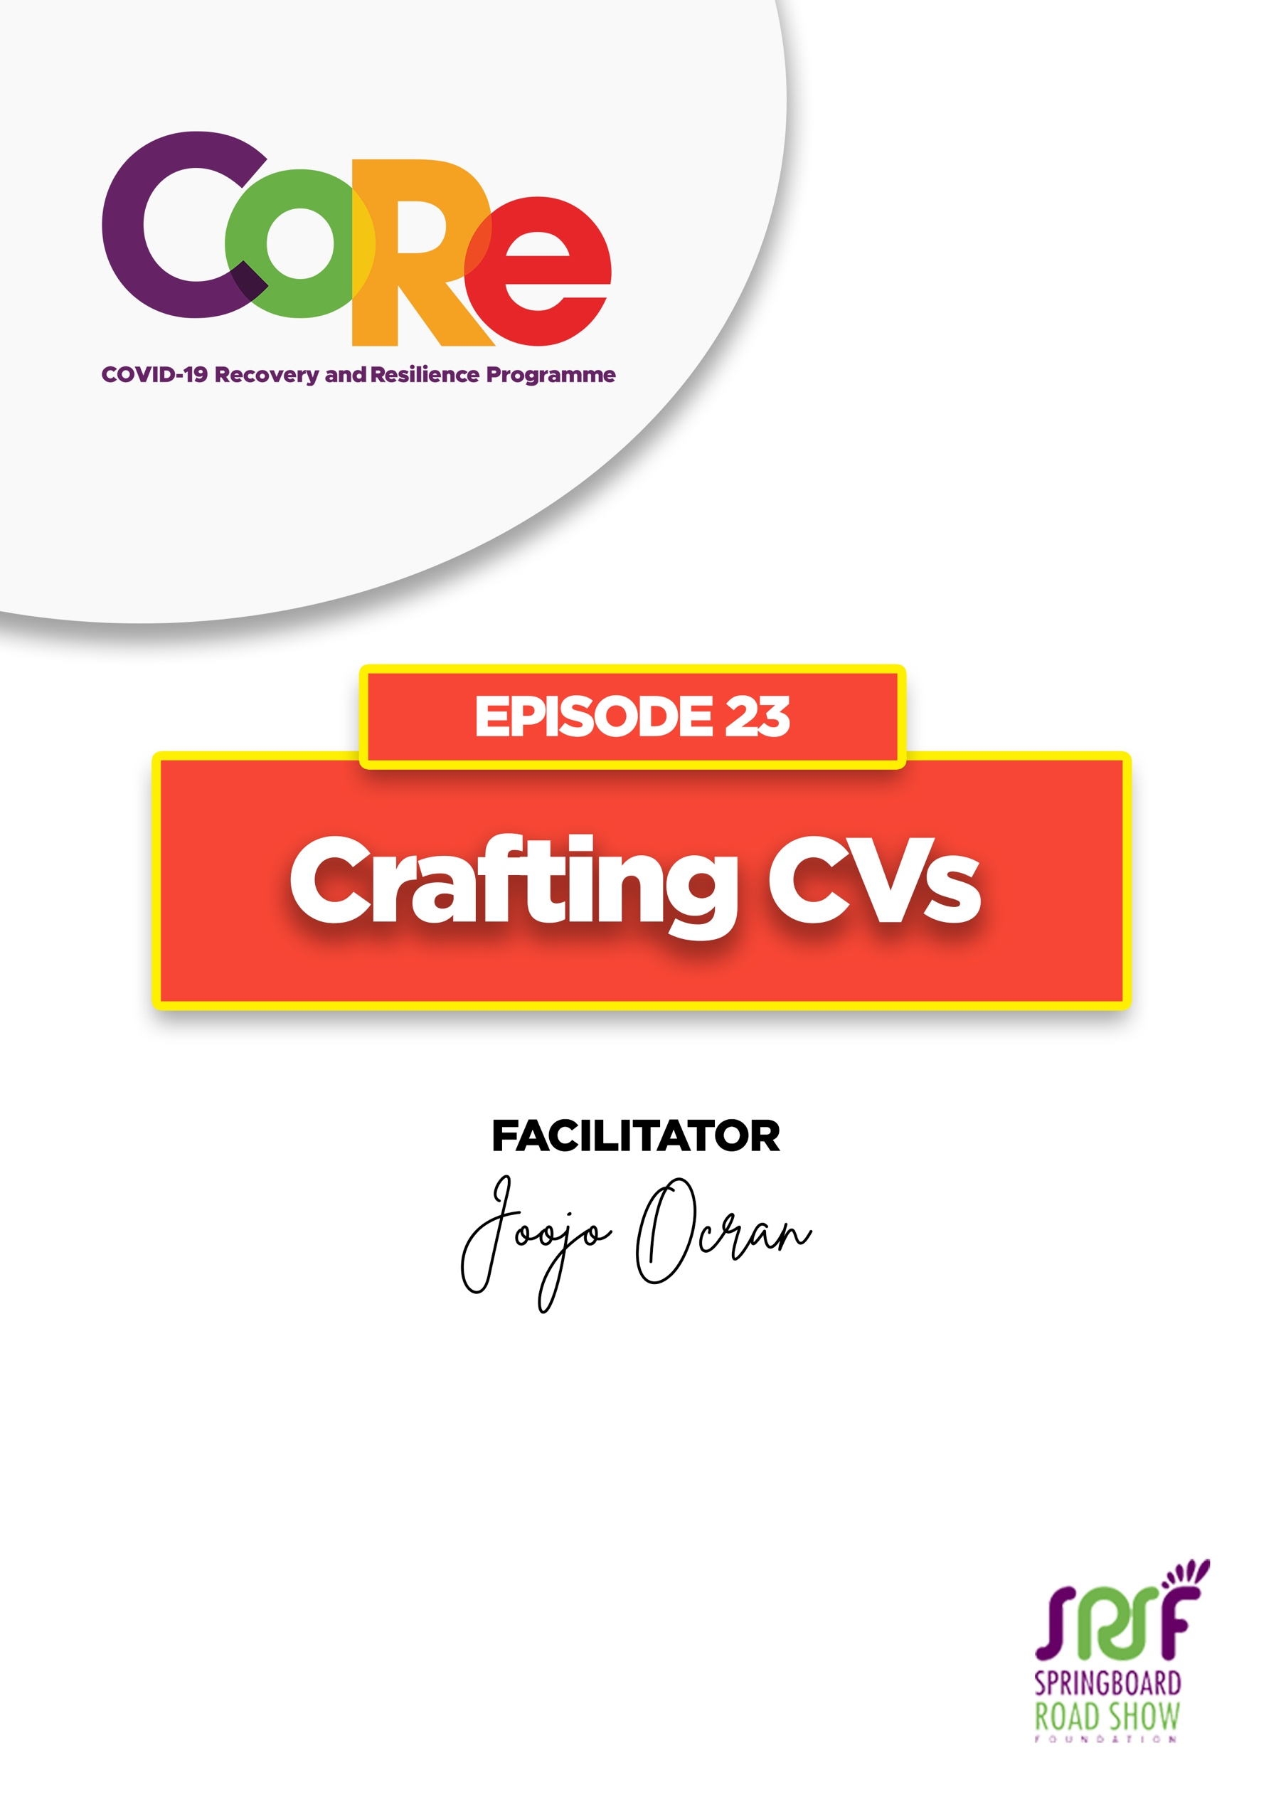
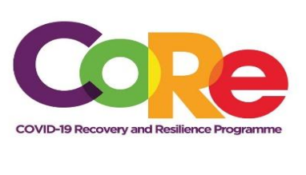


A partnership between



WORKBOOK
This workbook is a personal guide designed to accompany the CoRe Programme’s audio and video lesson for the week. Download it for free on our website www.core.com.gh

Name: _____________________________________________________________________

Phone Number: _____________________________________________________________

A CV simply is a summary of your education, your experience, your achievements, and your skills. It is a recap of what you have done so far in your career and educational life. It is simply the most common document that all reviewers ask for when you are applying for a job.

Parts of a CV
Name: Make sure it's your government name or the name that you are most commonly known by and make sure that the name is consistent across your CV, your cover letter, and any other application documents you use.
Contact Information: Ensure that your contact information is up to date because nothing is more painful than if you get the position or get to the interview stage and nobody knows how to reach you. Make sure your contact information is up to date.
Profile (Optional): This is an optional part of the CV, where some people enjoy or find valuable to give the employer an idea of what kind of candidate you are, and a summary of your skillset, etc.
Experience: This is where you go into what you have done so far in your career, your accomplishments, the various roles you have played. That is where you kind of break down that experience for the employer. Some people like to do a skills overview where they talk about the different skills and attributes that they bring to the position. That is a possibility, depending on how much experience and educational background you have
Education: People would like to know, where did you go to school? Whether it is Bunkurgu Yooyo high school or university, just make sure you include that. But after a certain stage, if you are past the college stage, you want to start taking out things from when you are in high school, because you are past that point.

Building your CV step by step
Name and contact information: Use your official name, make sure you include a mailing address in case they need to send you physical documents. Add your phone number, please ensure that the phone number(s) are always reachable. Use your official phone number, and finally include an email. Make sure it is an appropriate one. No sexymapooka@hotmail.com, try your first name, your last name@gmail.com. Something simple, something professional, and try and use a more current email provider.
Professional Experience: Make sure that whatever experience you are putting there is an experience that aligns with the job that you had trying to get. Focus on your skills and achievements. Tell them what you DID, not what you are responsible for. Provide details where needed if your job is something that maybe people would not necessarily know off the top.
Quantify Your Accomplishments, Use Numbers: If I see that you improved maybe revenue of your department by 20%, it is much more impressive than telling me that you played a role in improving department's revenue.

Move your CV from zero to a hundred
7.4 seconds, that is how much time the reviewer takes to glance through the average CV to see whether it's even worth going through in detail. So, you have less than eight seconds to make a strong first impression and be memorable to a reviewer, make it count. These are some of the things to just think about and to look out for when you are reviewing your CV:
Spellcheck: 40% of reviewers will simply throw out your CV if they see spelling mistakes and basic errors. Take your time. While it is frustrating to check for spelling mistakes in your CV before sharing it, that step can be the one that wins you the job.
Proofread: Go over your CV word by word, line by line and ask somebody else to review it for you. It really helps, because sometimes when we review our own work, we miss things because we think we have said them.
Take out the Deadwood: Remove things like a profile or your references or career objectives. At the end of the day, people want to know how you can solve their problem. So by removing deadwood, you are eliminating that information to make room for the more important things in your resume like your accomplishments, your skills, and your experience. Make sure you add numbers because numbers are what will really stand out to the reviewer and really wow them.
Fonts: Consistency, if in your first paragraph, you are using Times New Roman, don't use Arial in the next paragraph. Make sure that you are consistent in your text in your formatting in every part of your resume, make sure you're being consistent.
Saving your resume: Do not save your resume or your CV as “CV”, because at the end of the day, while, maybe on your computer, there's only one CV, in the reviewer's computer, they might be 1 million. So, make sure you save it as first initial, for me for instance, it would be “J” then my last name so “J. Ocran” then underscore CV (J.Ocran_CV). So first initial, last name, underscore CV. That is how you save your CV.

Four top tips for a “killer” CV by Joojo Ocran
- Use the job description: The job description is almost like you are going to an exam and somebody has just given you the marking scheme. Break down the job description and take your time to review it. Look out for all the terms and requirements used in the job description and make sure that they are reflected in your resume or in your CV in some way. But ensure that the essence behind what they are looking for is present in your CV.
- Add numbers: These are facts and figures, the statistics that make you stand out from the average candidate
- Update your contact information: People lose out on their dream jobs just because we cannot reach them. So, ensure that your resume has updated contact information.
- Don't send your resume or your CV on the deadline of the application. Even if it's been ready for a month and you send it on the deadline day, your reviewer will get the impression that you are a last-minute person.
Share 3 key lessons you have learnt from this episode

_________________________________________________________________________________
______________________________________________________
______________________________________________________
______________________________________________________
______________________________________________________

Let us hear from you.
- What is the biggest lesson you have learnt from this episode and the workbook?
- What will you do with the lesson you just learnt?
- What question would you like to ask the facilitator?

Share your answers to these or any comments you may have on:
Facebook Page: https://web.facebook.com/CoReProgramme/
Twitter Page: https://twitter.com/CoreProgramme
Instagram Page: https://www.instagram.com/coreprogramme/
WhatsApp hotline (+233) 55 153 55 33 and we will respond to you within 24 hours.
