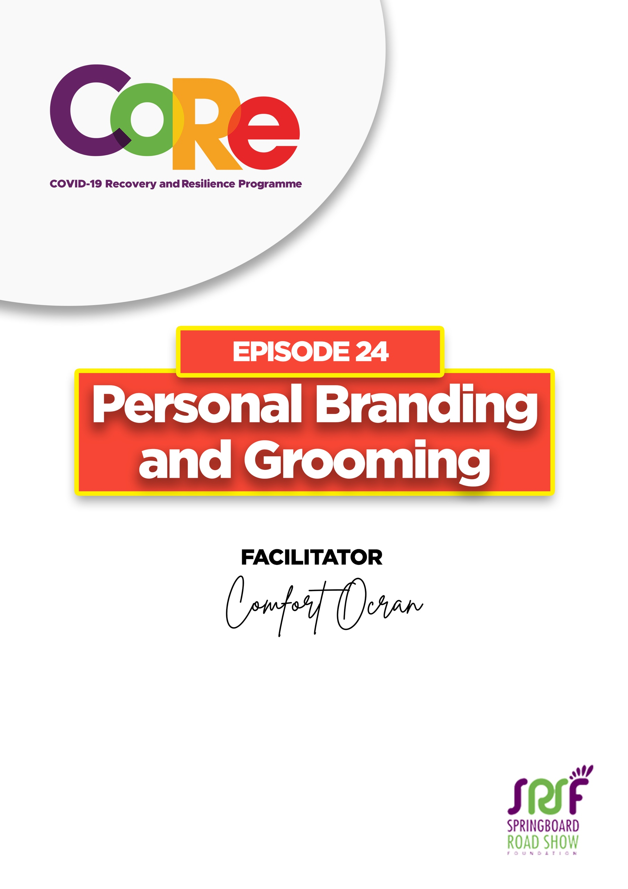
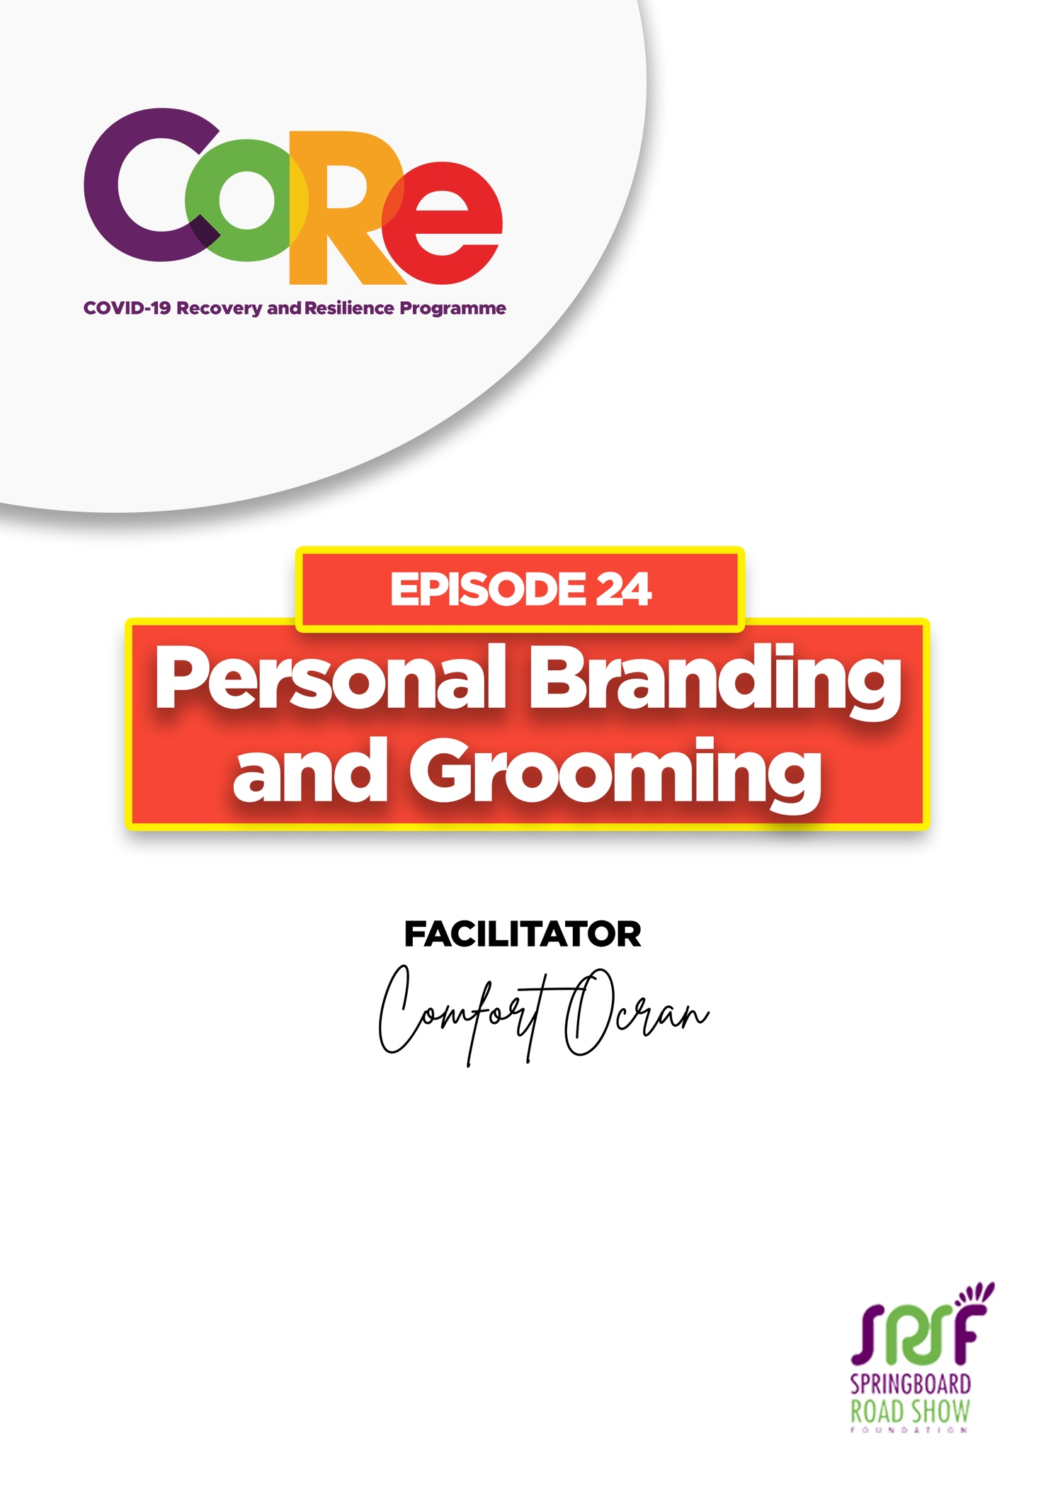
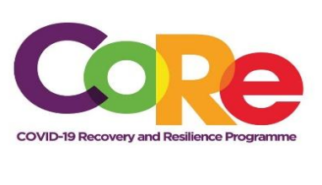


A partnership between



WORKBOOK
This workbook is a personal guide designed to accompany the CoRe Programme’s audio and video lesson for the week. Download it for free on our website www.core.com.gh

Name: _____________________________________________________________________

Phone Number: _____________________________________________________________

A Personal Brand is a perception or emotion that is kept by someone about you that describes your outstanding qualities and influences the person's perception about you.

What perception do people have about you? Is it a good or a bad perception?

What are your outstanding qualities? How does it influence a person's relationship with you?

A Personal Board of Directors is “a group of individuals you assemble in your mind for the purpose of navigating your career and life in general.” - Sandra Smith

You want to have people who are on your board because of their outstanding qualities. In the same way, as you progress in your life, build a brand that is authentic, filled with integrity, and extremely diligent.

If you had the opportunity of having some people on your personal board of directors from anywhere in the world, whether dead or alive, which three (3) people would you like to have on your personal board of directors?
a._______________________________________________________________________

b._______________________________________________________________________

c._______________________________________________________________________

We build our personal brand from three angles, Clarity, Confidence and Communication.
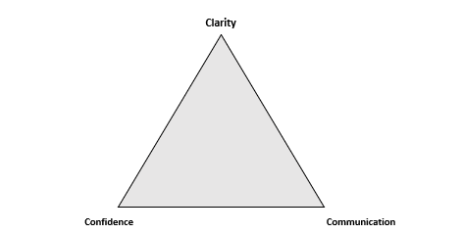

Clarity refers to you getting to know exactly who you are. You need to know your identity to find out who you really are. To identify who you really are, you need to ask yourself the following questions.
First ask yourself, “Who am I?” Your response could be: “I am a child of God” or “I love being an African.”
Secondly, “What are you capable of? What are your talents? For example: I enjoy having people, especially young people around me.
Thirdly, “What are your values?”, “What values do you have?” or “What values do you hold dear?” Your values may include integrity, humility, diligence, excellence, etc. Your values will determine what you do when you are put under extreme pressure. Values are extremely important because it builds trust and opens opportunities for you in life.
Clarity involves knowing your identity, knowing your values, and knowing what you can do. You need clarity about your identity, your capacity, and your values.

Confidence is built on your personality, your professionalism, your piety, or your religious outlook, as well as your physical attractiveness. How professional are you when people deal with you? Can they always trust what you give them or is it possible that today they will come to you and the next day you would not be found there because you are non-existent?

Communication is both verbal non-verbal, written, or physical. Always have a smile on your face. Your physical appearance and your body language tell people whether you are somebody they would love to have a hangout with. Your verbal tone and speed must also be appropriate, do not speak too fast because it gives the impression that you are very nervous, and speaking too slow is also boring and people will not enjoy your conversations. Keep it midtempo, not too fast or slow.

Personal Grooming refers to an art which helps individuals to clean and maintain their body parts. That is the cleaning and maintaining every part of the body for a pleasing appearance.
Ideally, we should wear colours that are subtle and wear clothes that are comfortable, but not too tight. If you are a singer or someone who is in public space and or an artiste, then you can wear colours that are blinding. At the workplace, subtle colours like Navy, Charcoal, Gray, Brown or Black, are ideal and you can offset that with inners like white.

Men
Suits: Ensure that your suits are the right size. When you button it up, leave the last button unfastened, that is the way to wear the suit. When you sit down, unbutton your jacket and when you get up, button it back up and leave the last button and back button.
Shoes: Your shoes must be well-polished. If you walk in the sun and get to the office with dirty shoes, always have as a backup a handkerchief/duster that you have dedicated to your shoes, just before you step into the office, polish your shoes neatly and step into the office.

Ladies
Do not wear flashy jewellry. Keep subtle jewellries when going to the office. When you are going out, then you can wear anything that you like. When going to the office, wear, tiny earrings with just enough makeup to make your face attractive. You must ensure that your nails are well-polished or well-groomed and neat. For office wear, do not have distracting things.

Good personal grooming also includes your body odour. Your body odour can either make or unmake you. Make sure you smell clean and fresh but not too overpowering.

Additionally, your undergarments also play a role in how you smell, wash your undergarments every day, so you do not use old undergarments.

What benefits would you get from applying the learnings from this lesson?

Let us hear from you.
- What is the biggest lesson you have learnt from this episode and the workbook?
- What will you do with the lesson you just learnt?
- What question would you like to ask the facilitator?

Share your answers to these or any comments you may have on:
Facebook Page: https://web.facebook.com/CoReProgramme/
Twitter Page: https://twitter.com/CoreProgramme
Instagram Page: https://www.instagram.com/coreprogramme/
WhatsApp hotline (+233) 55 153 55 33 and we will respond to you within 24 hours.


