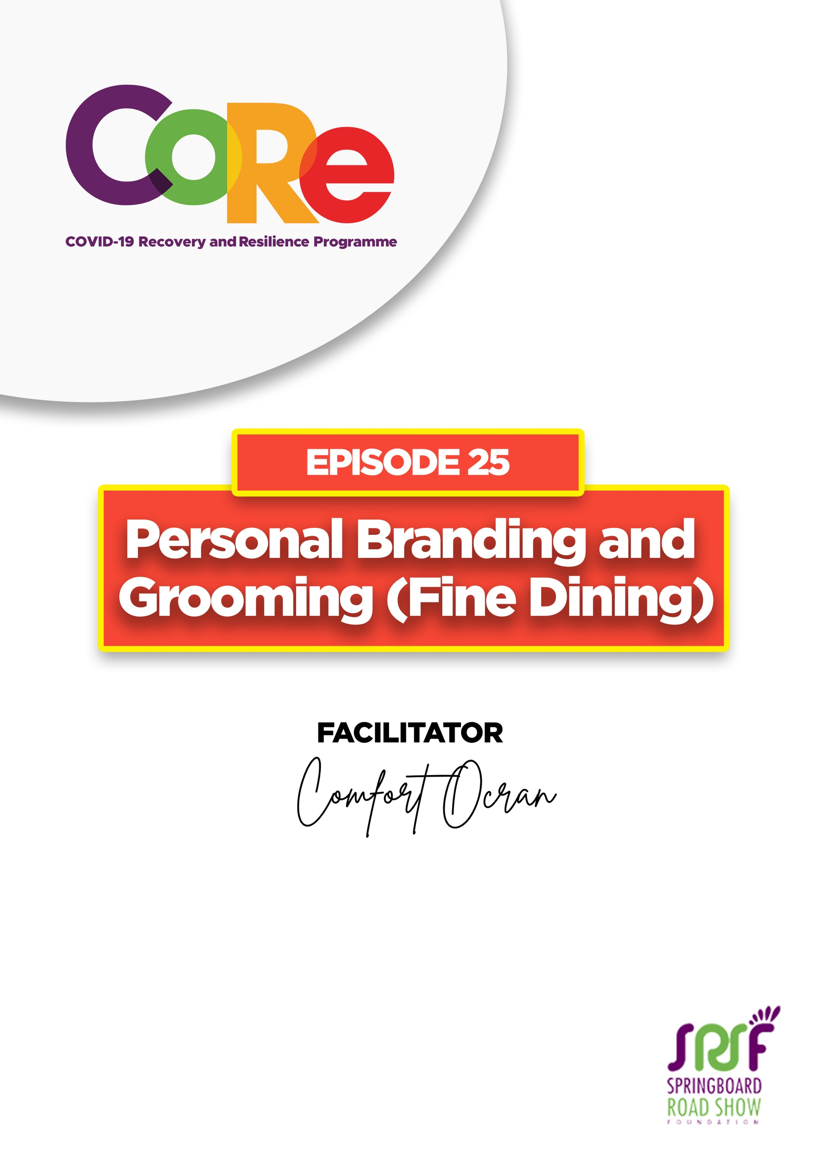


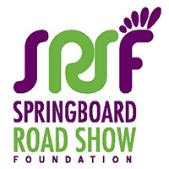
A partnership between
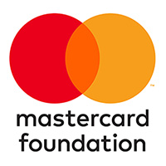


WORKBOOK
This workbook is a personal guide designed to accompany the CoRe Programme’s audio and video lesson for the week. Download it for free on our website www.core.com.gh

Name: _____________________________________________________________________

Phone Number: _____________________________________________________________

Fine Dining is the practice of dining in a formal setting, be it at a restaurant or at an event. The food is served in courses.
A course is a specific set of food items that are served together during a meal. A course may include multiple dishes or only one; it often includes items with some variety of flavours.
A three-course meal consists of three parts that are served one after the other. A three-course meal primarily consists of an appetizer (soup or salad), main course, and dessert.

Table set up for a Three-Course Meal
The average table setting for a three-course meal looks like the picture below. Do notice the placement of the items.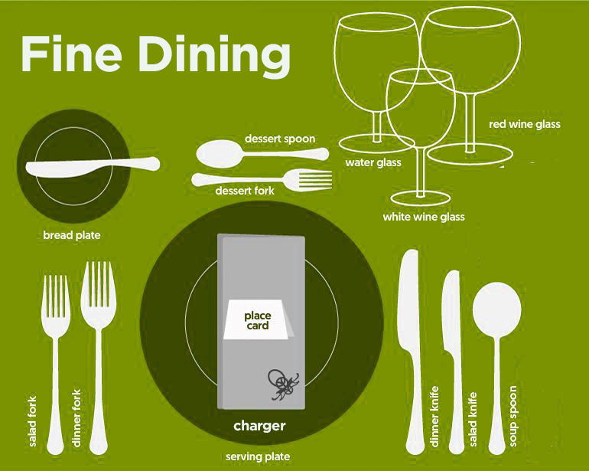

At the table, you would have a soup plate, a main or dinner plate, and then the charger or the serving plate. Notice that your side/bread plate is always to your left and the glasses you drink from are to your right. Kindly remember not to serve or eat from the charger or serving plate.

When you sit down, take your napkin from the napkin holder, open your napkin and put it on your lap gently. It is supposed to be used to gently dab your mouth should there be any spill as you eat.

Cutlery
Some people get confused when they see the amount of cutlery on their dining table as they do not know what to use first. Usually, your forks will be on your left, and your knife and spoon will be on the right. The salad fork is usually the leftmost fork followed by the dinner fork. On your right, you have your soup spoon as the rightmost cutlery, which preceded by salad knife, then the dinner knife. The dessert cutlery is always at the top of the setting. (Please refer to the picture above.)

Follow this simple rule of thumb, start from the outside and work your way inside. Depending on what food is being served, start with either the soup or salad cutlery, continue with the dinner cutlery, then complete your meal with your dessert cutlery.

When you are using the fork, turn the fork over, place the fork in the middle of what you are about to eat. Cut with the appropriate knife (use a salad knife for salads or a dinner knife when eating your main dish) if you need to cut anything. Cut it neatly, and gently. Place your forefinger be at the back of the fork so you have a firm grip as you slice your food. Do not take the meat or fish and struggle with it in your mouth. It is not fine dining.

Talking at Meals: When you are talking to your tablemates, put your cutlery down and converse with your mates. After talking, take your cutlery again and continue your meal.

Finishing your Meal
When you finish your meal, remember to put the cutlery together and place them on the place. If your plate were a clock, think of placing your cutlery at either the 4:20 position or the 6:30 position. This conveys a message to the waiters in the room that, you have finished your meal and therefore they can come for your plate and your cutlery.
Only put your cutlery together when you have finished your meal; if you have not finished, always have them apart.

Serving a Meal at the Buffet Table
When you go to the buffet table, take a reasonable amount of food. Please do not heap food on your plate as if this is your last meal after which there is no more food left in the world. Take a little at a time. When you heap your plate, you convey the message that you are not well-groomed.

From today’s episode:

- What inappropriate table manners/etiquettes would you stop practicing?
________________________________________________________________________
________________________________________________________________________
________________________________________________________________________________________________________________________________________________

- What positive table manners/ etiquettes are you going to practice?
_________________________________________________________________________________

_________________________________________________________________________________

_________________________________________________________________________________

_________________________________________________________________________________

Let us hear from you.
- What is the biggest lesson you have learnt from this episode and the workbook?
- What will you do with the lesson you just learnt?
- What question would you like to ask the facilitator?

Share your answers to these or any comments you may have on:
Facebook Page: https://web.facebook.com/CoReProgramme/
Twitter Page: https://twitter.com/CoreProgramme
Instagram Page: https://www.instagram.com/coreprogramme/
WhatsApp hotline (+233) 55 153 55 33 and we will respond to you within 24 hours.


