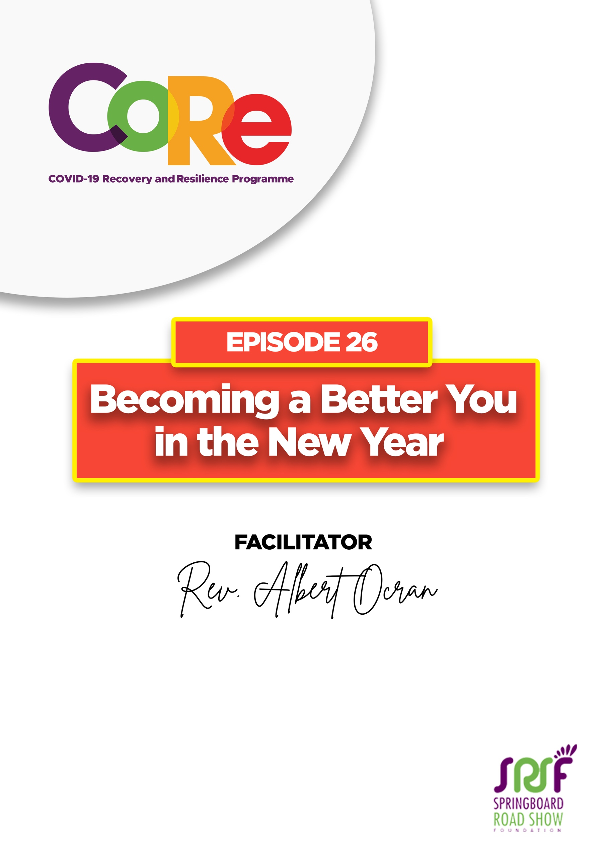
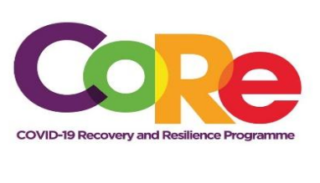


A partnership between



WORKBOOK
This workbook is a personal guide designed to accompany the CoRe Programme’s audio and video lesson for the week. Download it for free on our website www.core.com.gh

Name: _____________________________________________________________________

Phone Number: _____________________________________________________________

The version of yourself in 2021 must be better than the 2020 version, and the 2022 version must also be an improvement on the version of 2021. Every year is a 365-chapter gift from God, which you must use to its maximum and never stop striving to become a better you.

26 Tips for becoming a better you in the New Year by Rev. Albert Ocran
TIP | MEANING & EXPLANATION | WHAT I WILL DO TO ACHIEVE THIS IN 2021
A – Anticipation | Anticipate the opportunities that will come in the New Year, the doors that will open in your field or business. Anywhere you see the opportunities, be ready and move in that direction.
B - Boundary-less Learning | Learn from different models being used all over the world. Find out what is working in other countries and implement it in your work, your education or your business.
C – Competition | Be competitive in whatever you do. Determine to stand out from the competition by offering higher quality, better prices or superior service than others are offering in your field.
D – Decisiveness | When a door opens, move! Don’t stand there singing, “Do I go to the left or do I go to the right?” In 2020, it was those who spotted opportunities and moved quickly, who were able to take advantage and make it. Those who responded slowly were always caught flat-footed. Decisiveness is key.
E – Efficiency | Do the best with whatever assets God has given you. Get the best from the little you have. Do not waste resources or use them frivolously. Use a little to achieve much in the New Year. That is efficiency.
F – Flexibility | You may be comfortable with doing things in a particular way, but the world is shifting in new directions. Schools, churches and businesses are now doing a lot online. 2021 will come with new changes. Be flexible and adapt quickly.
G – Growth | Everyone must aspire to grow in the new year. Make a deliberate effort to improve in one way or another.
H – Honesty | Do genuine and honest business with people. Always deliver more than you promise. When people trust you, it will open more doors to you. It is called Reputational Equity. A good name is better than riches.
I – Indisputable | You must be the number one in what you do. There must be something you do that makes you better than everyone in your field. Train, rehearse and prepare. Whenever your name is mentioned, people must say you are the champion in your chosen field.
J – Judgment | Know when to do what. Critically think about what to do at every time.
K – Knowledge | Be knowledgeable about your field. Be an expert. Research, read about and master all the important details.
L – Leveraging | Everything God gives you is in its raw form. Leveraging is adding new layers to your work to increase your value. An interior decorator can write a magazine about their field or even start an apprenticeship programme.
M – Measurement | If you cannot measure something, you cannot check your progress. You must be able to measure your output in every area. Do not guess, always measure to monitor your progress.
N – Networks | When you deliberately build valuable relationships, they give you an advantage in life. It is called ‘Relational Equity.’
O – Opportunity | God will open doors for you in the New Year. But you must learn to enter those doors and take advantage.
P - Presentation Skills | You must master the ability to share your ideas, present your products or services and convince audiences wherever you go.
Q - Questions | The quality of questions you ask and the answers you provide to questions people ask you, will determine how far you reach in life.
R - Reinvention | Make yourself a brand new electrician, pastor, teacher, farmer or student. Create a new brand and keep moving forward.
S - Sheba | When people hear about you, and they come to look for you or do business with you, they must always say like the Queen of Sheba that the real you is even better than what they heard about. And they must tell others. That is the Sheba Principle.
T - Technology | You can’t progress in today's world without technology. Start with basic ones like email, WhatsApp and Facebook and move to more complex ones. Apply technology to your work and make progress.
U - Uniqueness | Don’t envy anyone. Appreciate who God made you. Find your place of strength, be excellent in it and you will enjoy life. Never think that God made a mistake. Every part of you is part of your advantage.
V - Vital Functions Theory | You can improve by 100% in the New Year by improving by 10% in seven key areas of your life. A 10% improvement in your spirituality, finances, career, relationships, health and personal development will lead to a 100% life improvement.
W - Win-Win | Life is not about us alone. We live in a community, work with people and have stakeholders, clients and friends. When you learn to win and for others to also win, you create a win-win situation for everyone.
X - X-factor | There must be something people cannot easily explain that makes you stand out. That is the X-factor that opens doors for you.
Y - Yearning | If you do not yearn or desire or hunger for progress, December will come, and you will be asking, “where did the year go?” Have a strong desire, pursue your goals and you will accomplish them.
Z - Zest | Do what you love, love what you do and enjoy the journey. There will be some exciting days and some tough days in the year. But wake up every day, ready to run and ready to fight. Let every single day of this year be a wonderful experience.

Which of the 26 tips for becoming a better you was your favourite? Why?

Let us hear from you.
- What is the biggest lesson you have learnt from this episode and the workbook?
- What will you do with the lesson you just learnt?
- What question would you like to ask the facilitator?

Share your answers to these or any comments you may have on:
Facebook Page: https://web.facebook.com/CoReProgramme/
Twitter Page: https://twitter.com/CoreProgramme
Instagram Page: https://www.instagram.com/coreprogramme/
WhatsApp hotline (+233) 55 153 55 33 and we will respond to you within 24 hours.


