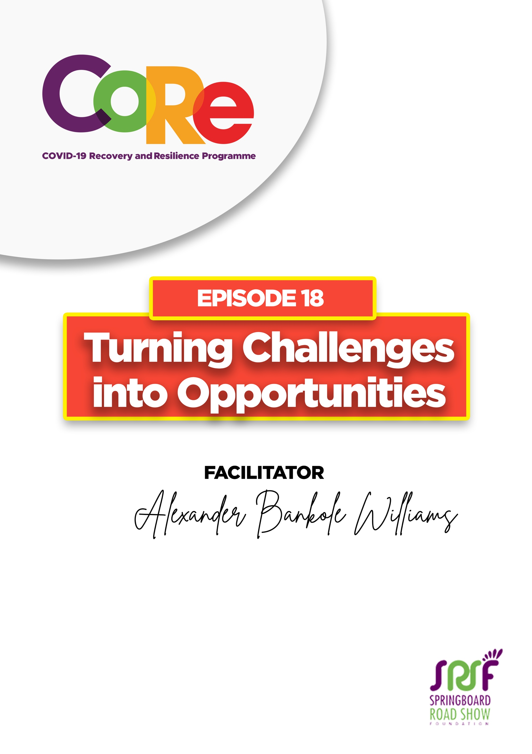

A partnership between

WORKBOOK
This workbook is a personal guide designed to accompany the CoRe Programme’s audio and video lesson for the week. Download it for free on our website www.core.com.gh

Name: _____________________________________________________________________

Phone Number: _____________________________________________________________

A Challenge is something new and difficult which requires great effort and determination to overcome. A Challenge is also any situation, mostly unpleasant that confronts your means of operating or your way of living or confronts how you ought to be in a negative manner.

How you respond to a challenge you are confronted by is what becomes a positive game-changer or a negative game-changer that determines whether you go down an abyss or you climb up to Mount Everest and shine.

- Have you encountered a challenge recently? How did you respond to it to either climb up higher or go down?

Change is often said to be the only thing in life that is constant. If you are ready to adapt to change, then you are ready to swing on to higher heights.

- Have you experienced any change or changes in the last 12 months? Kindly share with us.

How to turn your challenges into opportunities by Alex Williams
- Accept your new position in life: Accept who you have become and the situation you find yourself in. Define at that moment the hope within your hopelessness.
- Be willing to adapt: Acquire relevant new skills to help your new situation.
- Stay relevant in life: Do something to keep you relevant to whoever is around you or the entity you serve either by acquiring new skills or adapting to new ways of doing things.
- Be honest with yourself about what you have become: Evaluate your strengths and your weaknesses and decide on the way forward.
- Be open and ready to make amends about how you would move forward.

- Do you know of a friend or relative who has encountered a challenge? Share with us how he/she overcame it.
________________________________________________________________________
________________________________________________________________________
________________________________________________________________________
________________________________________________________________________
________________________________________________________________________

Let us hear from you.
- What is the biggest lesson you have learnt from this episode and the workbook?
- What will you do with the lesson you just learnt?
- What question would you like to ask the facilitator?

Share your answers to these or any comments you may have on:
Facebook Page: https://web.facebook.com/CoReProgramme/
Twitter Page: https://twitter.com/CoreProgramme
Instagram Page: https://www.instagram.com/coreprogramme/
WhatsApp hotline (+233) 55 153 55 33 and we will respond to you within 24 hours.

