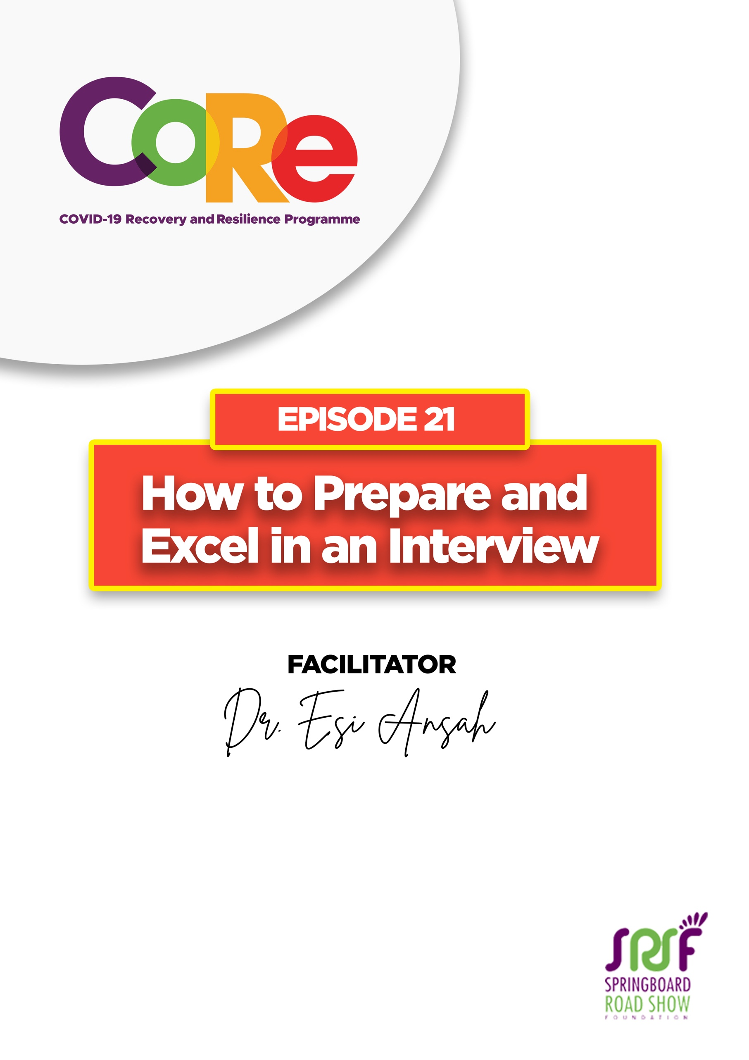

A partnership between
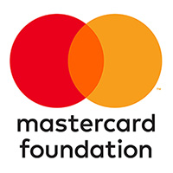
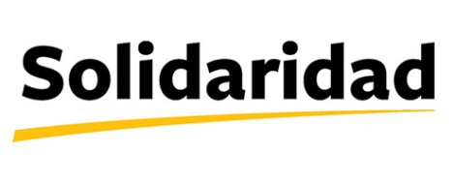

WORKBOOK
This workbook is a personal guide designed to accompany the CoRe Programme’s audio and video lesson for the week. Download it for free on our website www.core.com.gh

Name: _____________________________________________________________________

Phone Number: _____________________________________________________________

An Interview is a meeting in which someone asks you questions to see if you are suitable for a job or academic course. Anytime you receive an invitation to go for an interview, it means that somebody has seen something interesting about you and they want to meet you to learn more and understand more about you.

At interviews, you make sure that you put your best foot forward. As such, you make sure that if there are competitors, you are the one who comes out getting the job.

Have you attended an interview lately? What was the interview about? Kindly share

Interviews take different forms these days; that is, interviews may be in person or through an online virtual interview.

For Physical/ In-person interviews, make sure that you are at the location ahead of time. You may visit the place a day or two before the interview to familiarize yourself with the location and know how much time it takes to travel from your home to the location.

For Online / Virtual or Phone interviews, make sure that the technology is working properly before the time. If somebody tells you, we would like to interview you on Zoom, and you have never used Zoom before, go online, find out about Zoom, create an account and test it to be familiar with how to use it.

What mode/type of interview are you comfortable with and why?

Preparing for the Interview
On the day of an interview, always be on time. If your interview is at 9 am, make sure to be at the location by 8.45 am. Do not go too early for an interview, at least 15 minutes before time is fine.
Make sure you are properly dressed. Regardless of the company’s culture, be formally dressed. No jeans, no T-shirts, no "charley wote", and your dressing should not be flamboyant. Keep it simple and neat. For ladies, a nice skirt, or pair of trousers, that covers you nicely and a very decent shirt, which is not too tight.

At the interview
During the interview think of this acronym A-C-C-I.
A-Alignment: make sure that whatever they are looking for is what you are bringing, and it is what you have. The job description is an excellent guide to help you determine alignment.
C- Competence: whenever you see a job advert, it tells you what they are looking for. For example, someone who can use a computer, someone who knows how to communicate with other people, etc. Make sure that you have the competence and have all the requirements they are looking for in a candidate. You can build your competence by practising and volunteering.
C- Confidence is important at interviews. Confidence is how you hold yourself up and how you look at people during interviews. However, in an interview, if you are looking away and you are not making eye contact, it suggests that you are not confident. Build the practice of looking people directly in the eye and talking comfortably with them.
I-Integrity is the most important thing. Don't go and lie, don't go and tell stories and things that are not true. Make sure you are yourself; you are being very honest and you are saying what you mean.

What was your experience at the last interview you attended? Kindly share

Three Tough Questions that people get asked at interviews

Tell me about yourself?
When asked this question, do not start with a response like; “I am a gentleman of 20 years and I've done this, and I've done that. I come from Kumawu and I've done that.”
You may respond by telling the interviewer about your experience, what you are doing now and what you are interested in.

Why you are interested in this job?
Start with a plan and break your story up into bits. Tell the interviewer about your plans and career interests and how they relate to/aligns with the goals and objectives of the organisation and also how you will contribute to achieving their goals through the role. That way, whatever you are telling the interviewer is well organized

How much do you want us to pay?
Always give a minimum salary you expect to be paid, never give a ceiling. Tell them the minimum that you would want to take when you tell of the maximum, you are indirectly asking them to keep their money if they have a bigger budget for the role.

From this episode, what one lesson have you learned and would apply during your next interview?

Let us hear from you.
- What is the biggest lesson you have learnt from this episode and the workbook?
- What will you do with the lesson you just learnt?
- What question would you like to ask the facilitator?

Share your answers to these or any comments you may have on:
Facebook Page: https://web.facebook.com/CoReProgramme/
Twitter Page: https://twitter.com/CoreProgramme
Instagram Page: https://www.instagram.com/coreprogramme/
WhatsApp hotline (+233) 55 153 55 33 and we will respond to you within 24 hours.

